The Role of Astrocytes in Promoting Glioblastoma Pathogenicity

Taili Gao

Introduction
Glioblastoma (GBM) is the most malignant and common type of brain cancer. It has an incidence of 3.21 per 100,000 population, and the median age of diagnosis is 64 years (Guo et al., 2021; Thakkar et al., n.d.). Survival is approximately 40% in the first year post-diagnosis and 17% in the second year. (Thakkar et al., n.d.) Glioblastoma has a five-year overall survival rate of around 5.6% (Perelroizen et al., 2022).

The current treatment for GBMs is usually surgery, followed by radiation and chemotherapy (Thakkar et al., n.d.). The median survival time for elderly individuals who only receive the best supportive care is less than four months (Arifianto et al., 2023). Even when maximal treatment involving surgery and chemoradiotherapy is administered, survival rates are 27–31% at 2 years and 7–10% at 5 years (Arifianto et al., 2023). Treating glioblastoma is difficult because of its location and resistance to drugs such as temozolomide (TMZ), which is used in chemotherapy against this disease (Guo et al., 2021).

One central area of research to develop more effective treatments focuses on the GBM TME. The TME plays a significant role in fueling tumor growth, metastasis, immune surveillance evasion, and drug resistance (Anderson & Simon, 2020). Specifically, recent studies have identified TAAs in the GBM TME as crucial players in this process.

It is believed that GBM arises first in noncancerous astrocytes (Arifianto et al., 2023; Thakkar et al., n.d.). After GBM develops, TAAs in the TME are exploited to benefit the propagation and survival of GBM. In the CNS, astrocytes are the most abundant cells (Perelroizen et al., 2022). They have diverse responsibilities, including providing structural support, regulating the blood-brain barrier, and stabilizing synapses, and can also control CNS inflammation and neurodegeneration (Perelroizen et al., 2022). TAAs differ from healthy astrocytes in several ways. For example, they have increased expression of immune-associated genes, transcription factors linked to supporting brain tumors, and genes associated with immunosuppression (Perelroizen et al., 2022). Notably, TAAs aid in tumor metabolism by transferring energy-producing mitochondria, as well as providing the cholesterol critical for cell growth and function (Guo et al., 2021; Perelroizen et al., 2022; Watson et al., 2023). Moreover, TAAs can recruit and induce TAMs to create an immune-suppressive TME (Perelroizen et al., 2022).

Despite recent findings on TAAs, the multitude of mechanisms by which they aid in GBM pathogenicity remains to be elucidated. The metabolic and immune aspects of astrocyte interactions with GBM need to be considered further. Understanding the role of TAAs and their interconnecting pathways could allow the identification of therapeutic targets and the development of effective treatments.

Astrocytes and Glioblastoma Tumor Microenvironment Interactions
Tumor cells induce changes within their host tissues (Anderson & Simon, 2020). The resulting TME supports the growth and progression of tumor cells (Anderson & Simon, 2020). GBM cells promote communication with both nearby and distant cells by stimulating the formation of junctions and connections, and the secretion of vesicles and exosomes (Nunno et al., 2022). Importantly, signaling by GBM cells can shift the phenotype of stromal cells to create the TME that protects and fulfills the needs of the tumor. In addition to cancer cells, the GBM TME consists of astrocytes, immune cells, stromal cells, vascular endothelial cells, and pericytes, all occupying various niches in supporting GBM (Vleeschouwer & Bergers, 2017). Of these cell types, it is important to note that GBM arises from astrocytes, and TAAs significantly continue to support its needs.

Astrocytes Mitochondrial Transfer
Due to the high energy demand of the growing tumor, increased cellular respiration causes hypoxia to be a common hallmark of TME (Venkatesh & Lou, 2019). In GBM, hypoxia can lead astrocytes to become reactive or morphologically and functionally modified (Pantazopoulou et al., 2021). Hence, TAAs take on a role that supports the tumor. One mechanism of the action of TAAs is the physical transfer of energy-producing mitochondria to cancer cells. This process can be mediated by tunneling nanotubes (TNTs).

The hypoxic GBM TME can promote the formation of TNTs (Venkatesh & Lou, 2019). TNTs are intracellular membrane protrusions composed of components like actin and microtubules (Yang et al., 2022). They can mediate the transfer of nutrients and nucleic acids, as well as ATP-producing mitochondria from neighboring astrocytes to tumor cells (Nunno et al., 2022; Watson et al., 2023). Recently, TNTs were suggested to be the main mode of mitochondrial transfer (Yang et al., 2022). The motor protein kinesin and mitochondrial Miro-1 protein carry mitochondria along the microtubule component of TNTs (Fairley et al., 2022) (fig. 1). The transfer of mitochondria could also occur through the direct contact of astrocytes and GBM cells (Watson et al., 2023). Specifically, the growth-associated protein 43 (GAP43) has recently been identified as a required component of this type of mitochondrial transfer and an inhibition target for future drugs (Watson et al., 2023).

Astrocytes have been identified as important donors of mitochondria (Perelroizen et al., 2022; Watson et al., 2023). After a stroke, mitochondria transfer has been observed to occur from astrocytes to neurons, where it helps with neurorecovery and neuroprotection (Watson et al., 2023). Mitochondria are well known for their role in energy generation via oxidative phosphorylation. Accordingly, the theft of mitochondria by cancer cells increases their energy production (Watson et al., 2023; Yang et al., 2022). Mitochondria have also been implicated in other processes, including apoptosis. In addition to increased respiratory capacity and resistance to oxidative stress, astrocyte mitochondria transfer increases cellular proliferative capacity, promotes cell cycle progression, and enhances self-renewal and tumorigenicity of GBM via intracellular signaling (Watson et al., 2023; Yang et al., 2022).

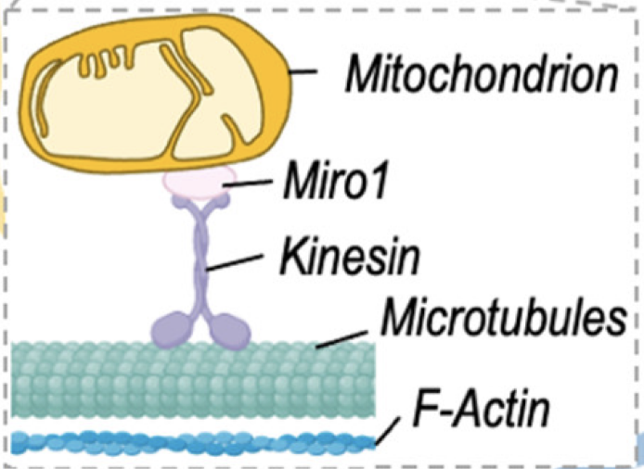
Figure 1 (Adapted from Fairley et al., 2022): The components of astrocyte mitochondria transfer via TNTs.

GBM-Astrocytes Cholesterol Metabolism
In the brain, cholesterol synthesis is mainly dependent on astrocytes (Guo et al., 2021; Perelroizen et al., 2022). In cells, cholesterol is needed for plasma membrane formation and signaling (Guo et al., 2021; Perelroizen et al., 2022). As tumor cells proliferate, they will need to produce more cell membranes. Cholesterol is an important component of the plasma membrane and is also used to synthesize crucial molecules such as steroid hormones and Vitamin D (Guo et al., 2021).

To support tumor growth in the TME, tumor cells require a higher level of cholesterol (Perelroizen et al., 2022). However, GBM cells lack the ability to synthesize cholesterol de novo and depend on the uptake of extracellular cholesterol (Perelroizen et al., 2022). Astrocytes supply GBM cells with cholesterol by synthesizing and then releasing cholesterol to the TME (Perelroizen et al., 2022). Specifically, the shuttling of cholesterol from astrocytes to cancer cells is mediated by TAAs’ expression of the sterol transporter ABCA1 (Perelroizen et al., 2022). ABCA1 induces astrocytes’ cholesterol efflux and reduces the uptake of cholesterol by astrocytes (Guo et al., 2021). The production of cholesterol by astrocytes for cancer cells enables the survival of the tumor and fuels its growth (Perelroizen et al., 2022). Accordingly, the inhibition of cholesterol efflux from astrocytes halts tumor growth (Perelroizen et al., 2022). In fact, patients with reduced expression of ABCA1 had increased survival rates (Perelroizen et al., 2022) (Fig. 2).

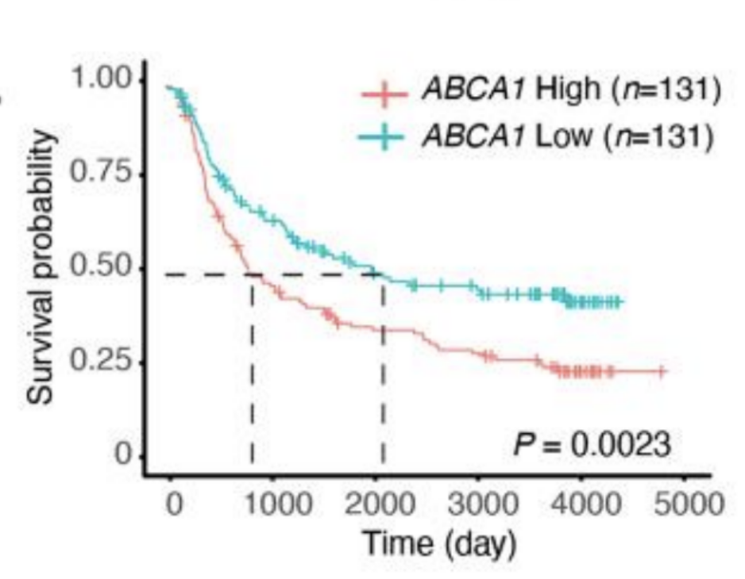
Figure 2 (Adapted from Perelroizen et al., 2022): Reduced ABCA1 expression associated with increased GBM patient survival.

Astrocytes-Macrophages Interactions
Astrocytes can mediate the establishment of an immune-suppressive GBM TME via interactions with TAMs (Perelroizen et al., 2022). Immune cells in the CNS are mainly microglia, a type of macrophage that is highly specialized and located in the parenchyma (Prinz et al., 2021). The action of microglia and nonparenchymal macrophages is ineffective against tumors due to the presence of immune-depressive cytokines mediated by GBM cells (Nunno et al., 2022). In the TME, macrophages can shift to an immune-suppressive phenotype and support tumor progression as TAMs. It is known that the number of TAMs in GBM has a positive correlation with the tumor malignancy grade and a negative correlation with patient survival (Perelroizen et al., 2022).

Given their range of abilities in the CNS, astrocytes can recruit macrophages to the tumor by increasing brain-blood barrier permeability and secreting chemokines, signaling proteins that stimulate the migration of leukocytes (Perelroizen et al., 2022). Indeed, TAAs directly control the recruitment of macrophages to GBM TME (Perelroizen et al., 2022).

Furthermore, TAAs hinder macrophages’ actions against GBM and induce the shift for macrophages to an immune-suppressive phenotype in GBM TME (Perelroizen et al., 2022). This process is at least partially dependent on TAAs’ modulation of nitric oxide (NO) metabolism in the TME (Perelroizen et al., 2022). It is known that macrophages expressing the inducible nitric oxide synthase (iNOS) induce GBM cell death (Perelroizen et al., 2022). However, TAAs can inhibit microglial induction of Nos2, the transcript encoding iNOS, through the secreted signaling cytokine Macrophage colony-stimulating factor (CSF1) (Perelroizen et al., 2022). In fact, astrocytes prevent the microglial-dependent killing of glioma cells by 48% on average (Perelroizen et al., 2022). Moreover, it has been shown that depleting astrocytes reduces the expression of several genes associated with tumor-promoting properties of TAMs (Perelroizen et al., 2022). The transition to the immune-suppressive phenotype mediated by TAAs enables TAMs to contribute to tumor progression and resistance to immunotherapies (Perelroizen et al., 2022).

Present and Emerging Treatments for GBM
Traditional treatments with surgery followed by chemotherapy and radiotherapy only boost survival for a few months. There are several reasons for the ineffectiveness of current treatments for GBM. For example, astrocytes contribute to chemotherapy resistance by GBM, though the exact mechanisms by which this occurs are unclear (Nunno et al., 2022). Moreover, the aforementioned system of TNTs is likely responsible for the acquired resistance to ionizing radiation (IR) therapy and TMZ in chemotherapy (Valdebenito et al., 2020). In cancer cells that have acquired resistance to chemoradiotherapy, the DNA repair enzyme O⁶-methylguanine-DNA methyl-transferase (MGMT) reverses and repairs DNA damage done by IR and TMZ (Valdebenito et al., 2020). The transfer of MGMT via TNTs spreads cancer cell resistance to chemoradiotherapy (Valdebenito et al., 2020) (fig. 3).

The aforementioned properties of the TME have also led to the ineffectiveness of certain drugs. For example, the only FDA-approved drug targeting angiogenesis in GBM is bevacizumab, which failed to prolong patient overall survival partially due to the hypoxic TME (Nunno et al., 2022). Additionally, the novel CAR-T immunotherapy using engineered T cells could be ineffective in GBM due to the highly immune-suppressive TME (Nunno et al., 2022). The possibility of switching the TME from immune-suppressive to immune-active presents a favorable treatment option for GBM. An alternative immunotherapy under early assessment called CAR-M, which uses an engineered cell type of macrophage, could be more effective against GBM due to the previously described functions of TAMs, notably in creating the immune-suppressive microenvironment (Nunno et al., 2022).

Due to the novelty of these findings, treatments targeting astrocyte interactions have yet to be developed. However, players in these interactions have led to the identification of promising treatments such as CAR-M and potential targets such as TNTs and GAP43. While some mechanisms controlling GBM progression are unclear, interactions in the TME are highly involved and could be controlled in emerging treatments.
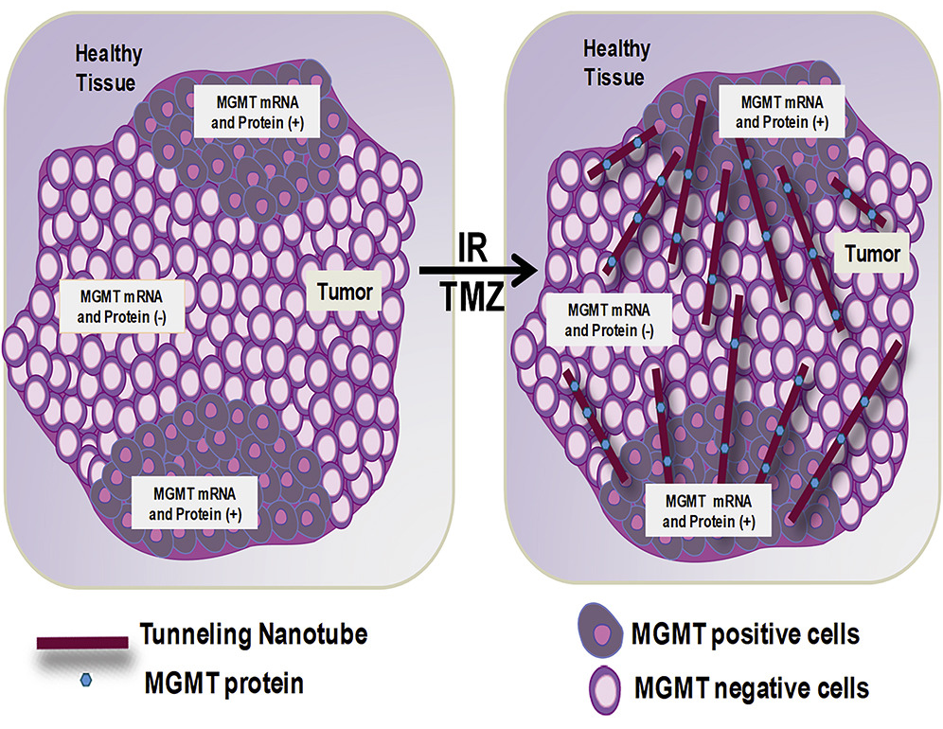
Figure 3 (Adapted from Valdebenito et al., 2020): The spread of acquired resistance to chemoradiotherapy through TNTs.

Conclusion
GBM is a fatal and common brain cancer lacking effective treatments. The systems of complex interactions in the TME ensure tumor survival. The immune-suppressive and hypoxic microenvironment offers resistance against the current treatment of surgery followed by chemoradiotherapy. Moreover, GBM cells induce changes in the phenotype of surrounding cells to fulfill their own needs. Notably, astrocytes are the most abundant cells in the CNS, and TAAs have key roles in promoting GBM pathogenicity. First, through the system of TNTs, astrocytes could act as mitochondria donors, promoting cell division and enhancing the tumorigenicity of GBM (Perelroizen et al., 2022; Watson et al., 2023; Yang et al., 2022). Second, GBM cells depend on TAAs for cholesterol synthesis (Perelroizen et al., 2022). Cholesterol is necessary for the formation of cell membranes and signaling molecules (Guo et al., 2021; Perelroizen et al., 2022). TAAs synthesize cholesterol and release it to be taken up by GBM cells, which enables the survival of the tumor (Perelroizen et al., 2022). Finally, TAAs interact with macrophages and induce them to create an immune-suppressive microenvironment (Perelroizen et al., 2022). TAAs also mediate the recruitment of TAMs to the TME (Perelroizen et al., 2022). The percentage of TAMs in the TME is negatively correlated with patient survival (Perelroizen et al., 2022).

While TAAs demonstrate the various ways GBM benefits from interactions in the TME, they also identify potential targets for future treatments. Due to the importance of astrocytes in driving GBM pathogenicity, eliminating astrocytes around the tumor could also eradicate the cancer cells. In fact, this procedure has been modeled in animals with success: the cancer was removed and all treated animals survived (Cornall, 2022). However, there are currently no tools for eliminating astrocytes in humans (Cornall, 2022). Future strategies allowing the removal of astrocytes precisely around the tumor could eradicate GBM. Another possibility is to target the specific molecules allowing the TAAs to aid GBM. For example, in astrocytes’ mitochondrial transfer, the inhibition of GAP43 or TNT formation could lead to successful recovery from GBM (Valdebenito et al., 2020; Watson et al., 2023). Recent findings have brought novel and promising treatment ideas, but these options also leave more questions for further research.

References
Anderson, N. M., & Simon, M. C. (2020). The tumor microenvironment. Current biology: CB, 30(16), R921–R925. https://doi.org/10.1016/j.cub.2020.06.081

Arifianto, M. R., Meizikri, R., Haq, I. B., Susilo, R. I., Wahyuhadi, J., Hermanto, Y., & Faried, A. (2023). Emerging hallmark of gliomas microenvironment in evading immunity: A basic concept. The Egyptian Journal of Neurology, Psychiatry and Neurosurgery, 59(1), 1-14. https://doi.org/10.1186/s41983-023-00635-5

Cornall, J. (2022, September). New study on astrocytes could lead to drug development for brain cancer. Labiotech.eu; Labiotech UG. https://www.labiotech.eu/trends-news/study-brain-cancer-astrocytes/

Nunno, V. D., Franceschi, E., Tosoni, A., Gatto, L., Bartolini, S., & Brandes, A. A. (2022). Glioblastoma Microenvironment: From an Inviolable Defense to a Therapeutic Chance. Frontiers in oncology, 12, 852950. https://doi.org/10.3389/fonc.2022.852950

Fairley, L. H., Grimm, A., & Eckert, A. (2022). Mitochondria Transfer in Brain Injury and Disease. Cells, 11(22), 3603–3603. https://doi.org/10.3390/cells11223603 ‌

Guo, X., Zhou, S., Yang, Z., Li, A., Hu, W., Dai, L., Liang, W., & Wang, X. (2021). Cholesterol metabolism and its implication in glioblastoma therapy. Journal of Cancer, 13(6), 1745-1757. https://doi.org/10.7150/jca.63609

Pantazopoulou, V., Jeannot, P., Rosberg, R., Berg, T. J., & Pietras, A. (2021). Hypoxia-Induced Reactivity of Tumor-Associated Astrocytes Affects Glioma Cell Properties. Cells, 10(3). https://doi.org/10.3390/cells10030613

Perelroizen, R., Philosof, B., Chernobylsky, T., Ron, A., Katzir, R., Shimon, D., Tessler, A., Adir, O., Meyer, T., Krivitsky, A., Shidlovsky, N., Madi, A., Ruppin, E., & Mayo, L. (2022). Astrocyte immunometabolic regulation of the tumour microenvironment drives glioblastoma pathogenicity. Brain, 145(9), 3288-3307. https://doi.org/10.1093/brain/awac222

Prinz, M., Masuda, T., Wheeler, M. A., & Quintana, F. J. (2021). Microglia and Central Nervous System–Associated Macrophages—From Origin to Disease Modulation. Annual Review of Immunology, 39, 251. https://doi.org/10.1146/annurev-immunol-093019-110159

Vleeschouwer, S. D., & Bergers, G. (2017). Glioblastoma: To Target the Tumor Cell or the Microenvironment? Codon Publications EBooks, 315–340. https://doi.org/10.15586/codon.glioblastoma.2017.ch16 ‌

Thakkar, J. P., Peruzzi, P. P., & Prabhu, V. C. (n.d.). Glioblastoma Multiforme. American Association of Neurological Surgeons. Retrieved July 23, 2023, from https://www.aans.org/en/Patients/Neurosurgical-Conditions-and-Treatments/Glioblastoma-Multiforme

Valdebenito, S., Audia, A., Bhat, K., Okafo, G., & Eugenin, E. A. (2020). Tunneling Nanotubes Mediate Adaptation of Glioblastoma Cells to Temozolomide and Ionizing Radiation Treatment. IScience, 23(9), 101450–101450. https://doi.org/10.1016/j.isci.2020.101450

Venkatesh, V. S., & Lou, E. (2019). Tunneling nanotubes: A bridge for heterogeneity in glioblastoma and a new therapeutic target? Cancer Reports, 2(6). https://doi.org/10.1002/cnr2.1185

Watson, D. C., Bayik, D., Storevik, S., Moreino, S. S., Sprowls, S. A., Han, J., Augustsson, M. T., Lauko, A., Sravya, P., Røsland, G. V., Troike, K., Tronstad, K. J., Wang, S., Sarnow, K., Kay, K., Lunavat, T. R., Silver, D. J., Dayal, S., Joseph, J. V., . . . Lathia, J. D. (2023). GAP43-dependent mitochondria transfer from astrocytes enhances glioblastoma tumorigenicity. Nature Cancer, 4(5), 648-664. https://doi.org/10.1038/s43018-023-00556-5

Yang, F., Zhang, Y., Liu, S., Xiao, J., He, Y., Shao, Z., Zhang, Y., Cai, X., & Xiong, L. (2022). Tunneling Nanotube-Mediated Mitochondrial Transfer Rescues Nucleus Pulposus Cells from Mitochondrial Dysfunction and Apoptosis. Oxidative Medicine and Cellular Longevity, 2022. https://doi.org/10.1155/2022/3613319

