Examining the Effects of Fracking on Groundwater: A Comprehensive Data Analysis of United States Fracking Well Data Nationwide
William Lin
Introduction
Hydraulic fracturing, colloquially known as fracking, has emerged as a pivotal technology in the global energy landscape, transforming the extraction of oil and natural gas from unconventional reservoirs. This drilling technique, characterized by its reliance on high-pressure fluid injection to induce fractures in subsurface rock formations, has sparked significant scientific, environmental, and socioeconomic discourse. While fracking has facilitated access to vast reserves of hydrocarbons, its rapid proliferation has prompted intense scrutiny due to concerns regarding its impact on the environment, public health, and social well-being.
During the process of fracking, several steps must be taken. Firstly, the area has to be prepared, which involves clearing the area, building roads and drilling pads, and analyzing the surroundings to prevent spills from damaging the nearby area. Next, a hole is drilled straight down into the ground. A steel pipe known as the surface casing is then installed, and cement is piped in between the walls of the hole and the steel pipe, where it sets. Extra sets of casing and walls may be installed depending on the area. At certain depths known as the “kickoff point”, horizontal drilling is done, using a similar process to the vertical drilling. Once this is finished, a perforating gun is shot into the wall, creating holes into the rock beyond the wall. A solution of chemicals, sand, and water is pumped at high pressure through these holes, widening the fractures. The sand is left in to widen the cracks, allowing oil and natural gas to flow in easier. Once this process is done, production of oil and natural gas begins as oil and gas flow into the well, and the fracturing fluid is recovered and processed. About 25-75 percent of the fluid is recovered, which is either recycled or disposed of. Once the oil and gas are drained from the area, the wells are filled with cement and the equipment is removed, with the land being returned to what it was before to the best of the landowner and the drilling company’s abilities.
Hydraulic Fracturing, What is it? Stages of the hydraulic fracturing water cycle
Source: https://hydrauliceconomics.weebly.com/ Source: https://www.epa.gov/hfstudy, Pg: ES10
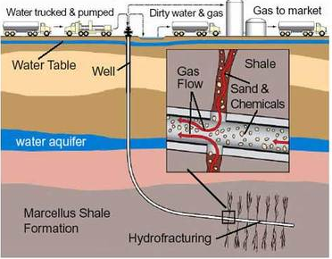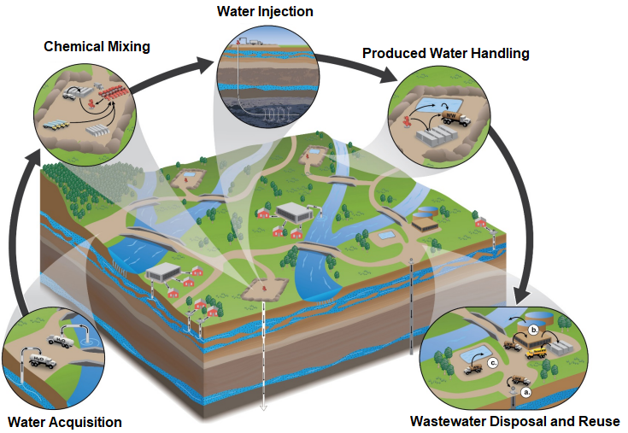

Currently, fracking plays a significant role in the United States oil industry. More than 1.7 million U.S. wells have been completed using the fracking process, producing more than seven billion barrels of oil and 600 trillion cubic feet of natural gas. According to the U.S. Energy Department, up to 95 percent of new wells drilled today are hydraulically fractured, which, according to the EIA in 2018, accounts for two-thirds of total U.S. marketed natural gas production and about half of U.S. crude oil production. This technique is a prominent focus with current natural gas and oil production, with it being more and more used over time.
A large amount of controversy around fracking focuses on its environmental impact. Fracking has a large potential to disrupt habitats due to its large land footprint, can increase seismic activity in the area, can increase air pollution, and has potential hazardous chemical exposure. A prominent focus on these concerns is that of groundwater, with the wastewater disposal and fracking injections potentially allowing hazardous chemicals to enter the groundwater. In this paper we will start with going over the current knowledge of how fracking affects the quality and accessibility of groundwater in the United States. Then we will conduct a comprehensive analysis on the fracking well water consumption data nationwide using the most current registry data available as of October 2023. To accomplish the research goals, we employ various statistical methods and machine learning techniques. We hope the insights gained from this research process can help to identify potential strategies for mitigating underground water consumption in the fracking industry.
Methodology
First, a comprehensive literature review was conducted. We focused on searching from research papers from academic journals such as Environmental Science & Technology, articles from government agencies such as the United States Environmental Protection Agency (EPA), and publications from the environmental science departments in colleges. To identify research papers and websites that have relevant information on fracking, we used a list of keywords to help to search for sources. The keywords initially used started with simply “fracking”, “groundwater”, “contamination”, “Texas”, and “pollution”. Later, the scope of the paper was expanded, and new keywords introduced were such as “United States”, “health”, “leeching”, and “aquifers”. Data from Government Agencies, Industry Reports, Academic Research, and Non-Governmental Organizations (NGOs) were collected, and sorted into categories for analyses. We then studied the research papers, articles, and data pertaining specifically to the effects on groundwater consumption and contamination in the fracking industry and its environmental implications.
Next we downloaded historical national hydraulic fracturing chemical disclosure data from FracFocus Chemical Disclosure Registry from https://fracfocus.org/data-download. FracFocus provides the release of hydraulic fracturing companies’ disclosure data to the public free of charge and is updated on a daily basis. The data are stored in CSV formats as well as in database table format that can be read using Microsoft SQL server 2019. There are three parts of the data elements that are included. 1) Table contains hydraulic fracturing company’s name, well name, well location, base water volume and total vertical depth. 2) Table contains each disclosure’s additive names and purpose for the additives used. 3) Table contains each disclosure’s chemical ingredients that are used in the additives and jobs. We then imported the downloaded data into a Python environment. The database covers registry data from around 1,800 companies with about 206,000 wells. The detailed registry table with additional data elements such as purposes for additives and ingredients has about 6.1 million rows. Since data may be manually entered into the databases, there are typos in some fields. We did some manual data fixes such as fixing the name of the states prior to analyzing the data. Statistical analysis such as distribution analysis, correlation analysis, regression analysis, and boxplot were used to examine the water consumption in wells and to explore which factors may affect the total water consumed by a well.
Thirdly, we use Natural language Processing (NLP) and Machine Learning techniques such as Cluster Analysis to extract and analyze the data when there is a need. For example, since the additive, purpose and ingredient data are stored in free text forms across over 6 million rows, it is hard to transform the data for analytical needs using traditional query methods. We tried several Natural Language Processing Python packages such as TF-IDF and NLTK to extract top keywords from the data fields for the entities. Then we created dummy variables, 1 or 0, to indicate whether a well has used or has not used certain ingredients identified by keywords such as “methanol”. Transforming the keywords into dummy variables allows us to use them as independent variables in a regression analysis and machine learning models in order for us to test the relationships between these factors and the independent variable, the total volume of water consumed. In addition, Machine learning techniques such as Logistic Regressions and Random Forest models are used to learn from the reported water contamination cases and to build models that may help to predict future violations on water quality. However, machine learning relies on learning from prior knowledge, but we ran into obstacles to obtaining the previous data that can be used as training cases. Since the water contamination violation reporting database is not easily obtained by the public, we searched online and identified several reports with information on companies that had reported violation cases. 1)Violations Per Well Among PA Operators. 2) Fracking’s Environmental Impacts: Water. 3) Fracking’s Most Wanted: Lifting the Veil Oil and Gas Company Spills and Violations. For companies that are mentioned in the reports, we created a water contamination violation flag, 1 being yes for contamination 0 being no for contamination. The violation flag is then joined back with other data from FracFocus at company level, which is then used to build the machine learning models. However, since we only have a limited number of violation cases, we do not have enough training data, therefore, more data needs to be obtained to enhance the accuracy of the models to predict companies that may have higher likelihood of having a water quality violation.

Results and Discussions
- Results from Literature Review
For the literature review, the keyword searches identified a couple of hundred research papers and websites, and we ended up reading about 50 articles for this research. The literature review section of this study has several key findings. Firstly, the presence of drilling wells was linked to higher concentrations of methane in drinking wells near the natural-gas wells. On a study done on 68 private water wells in Upstate New York as well as Northeast Pennsylvania, 60 of which were also analyzed for dissolved-gas concentrations of methane and higher-chain hydrocarbons and for carbon and hydrogen isotope ratios of methane, 51 out of those 60 had methane concentrations detected, with methane concentrations were 17-times higher on average (19.2 mg CH4 L−1) in shallow wells from active drilling and extraction areas than in wells from nonactive areas(1.1 mg L−1 on average). In addition, several harmful compounds have been detected in the wells near fracking sites in the Barnett Shale region of Texas, a region known for high fracking activity, such as methanol, ethanol, dichloromethane(DCM), several BTEX class compounds(benzene, toluene, ethylbenzene, xylene), arsenic, and strontium,. Studies done on the Marcellus Shale formation with samples from Indiana County, Pennsylvania, Chenango County, New York; and Yates County, New York showed that the process of hydraulic fracturing could cause radium to begin to leech into nearby areas, potentially contaminating aquifers. Lastly, the process of fracking is one that consumes a large amount of water, with the water use per well increased up to 770% from 2011 to 2016 and the EPA raising concerns over water withdrawal in areas with limited or declining groundwater resources.
From these results, a correlation between fracking and the lowered quality and quantity of groundwater in certain areas can be drawn. While a link between the direct contamination due to fracking can be formed, it cannot be concretely proven with current data, and we suggest that further studies be done on the matter to gain conclusive evidence. The increased water usage, however, can be concretely shown, and as more than half of the continental United States has experienced drought conditions with 40 of 50 state water managers expected shortages in some portion of their states over the next 10 years in 2014. This issue is one that should be addressed. Steps should be taken to either reduce the water usage done by fracking or to reduce the usage of fracking in areas that experience water shortages. The issue of direct contamination is one that warrants further studies, and as the fracking industry grows in the United States, drought conditions as well as concerns of contamination are likely to make the issue more contentious.

- Results from Data Analysis and Statistical Analysis
Using Python code, we analyzed the historical national hydraulic fracturing chemical disclosure data from FracFocus Chemical Disclosure Registry. The goal of this exercise is to examine the relationships between the total base water consumed by a well with other available data elements such as the total vertical depth, purposes for the additives used, and ingredients used in the job and additives. Since water resources are scarce in many regions, using large quantities of water resources in some regions significantly impacts the drinking water availability and even causes drought for the land near the fracking wells. Understanding the factors that may contribute to a surging underground water consumption in fracking wells can offer potential strategies to reduce water usage in wells.
The following chart breaks down by state for the 206,000 wells registered by the 1,800 companies historically. Texas accounts for about half of total fracking wells, followed by Colorado, Oklahoma, North Dakota, New Mexico, and Pennsylvania. 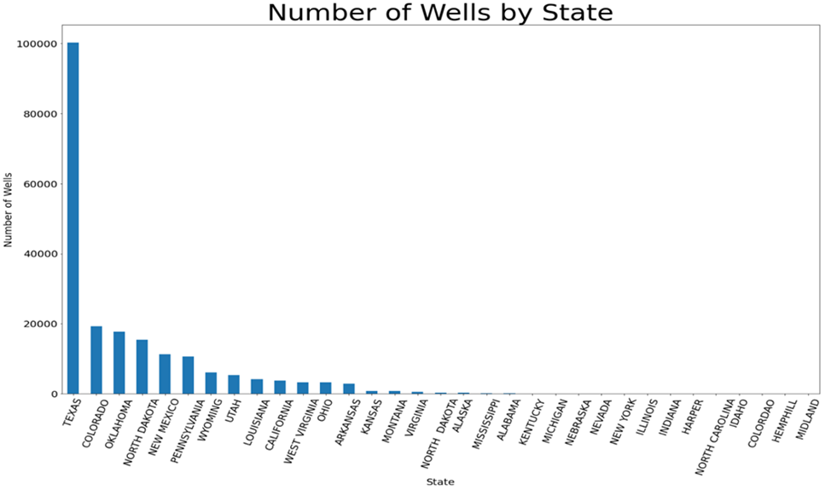
The next chart lists the operating firms with more than 1,000 wells registered historically. These firms tend to be larger operators that may have wells across different states. There are 6 companies which have registered more than 5,000 wells historically, EOC Resources, Anadarko Petroleum, Chesapeake, XTO, Pioneer Natural and Devon Energy. These operating firms constitute a big proportion of the total number of wells and the strategies that they are taking could have a significant impact on the total industry. Government agencies such as the United States Environmental Protection Agency (EPA) and organizations such as the Natural Resources Defense Council (NRDC) can set up on-going watch programs to monitor the practices of these firms to avoid excessive water consumption issues.
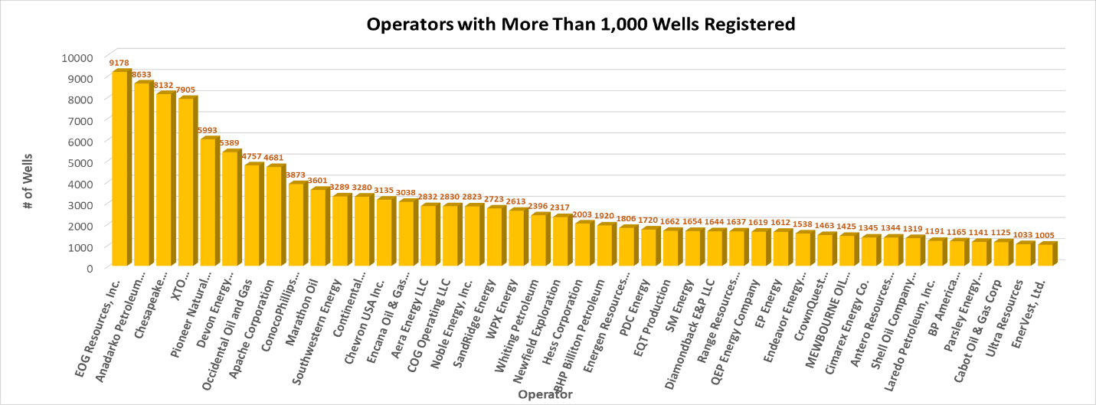

For the majority of the wells, the database provides data on two import measures, Total Base Water Volume (in gallon) and Total Vertical Depth of the well (in feet). As the first step, we ran some descriptive data analysis for the two measures, and then tried to evaluate whether the Total Vertical Depth of the well has a correlation with the Total Base Water Volume consumed in the well.
Since the Fracking database involves manual data entry that can be error prone, some of the wells showed extremely large TVD and Total Base Water Volume numbers and they are apparently inaccurate in many cases. Therefore, we decided to exclude all wells that had deeper than 25,000 feet in TVD and consumed more than 50 million gallons of water from our analysis. Out of about 206,000 wells, the database has TVD and base water data on about 177,000 wells. We exclude 73 wells with extremely large TVD, 140 wells with more than 50 million Base Water Volume. 2,000 Observations that do not have both measures are also excluded.
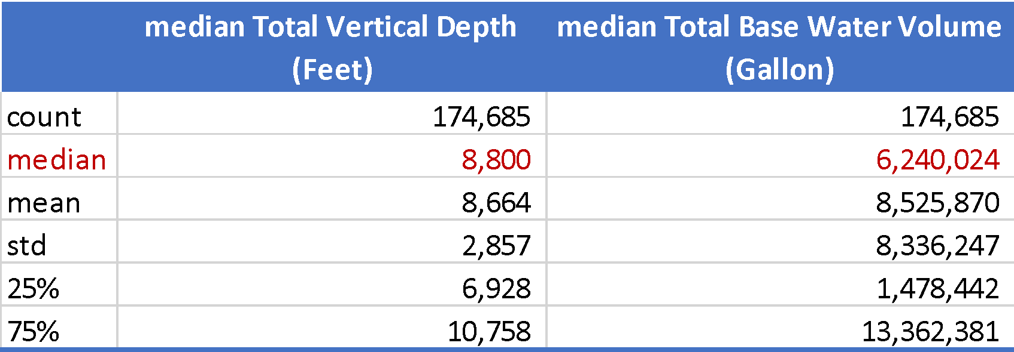
Based on the 174,685 wells registered in the US historically, median Total Vertical Depth is about 8,800 feet. The 25 – 75 percentile TVD is between 6,928 and 10,758. Media Total Based Water Volume used is about 6.24 million gallons per well. The 25-75 percentile water consumption per well is between 1.48 million and 13.36 million gallons. These numbers are consistent with what has been published from some other papers from my literature review.
Median TVD Median Total Base Water Volume
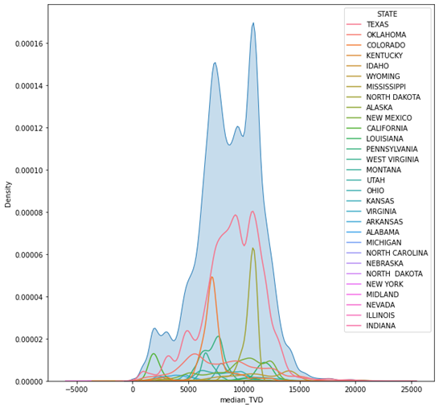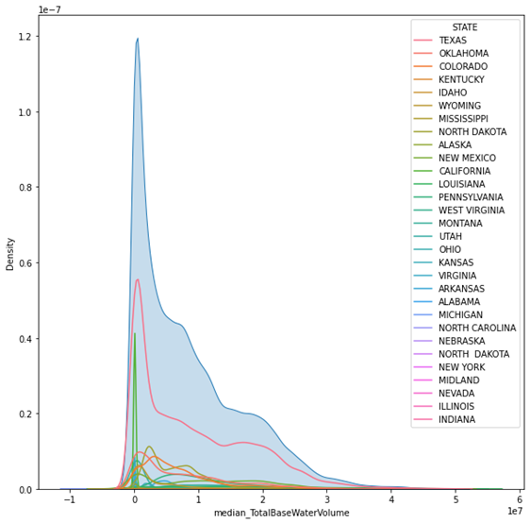
The above charts show the total and by state distribution curves for the two measures. The TVD distribution curves center in the middle, except that there are two spikes in around 7,000 and 11,000 feet in TVD values. The Total Base Water Volume distribution curve is right skewed, which means that a large proportion of the wells consumed less water but with outliers which had significantly larger water consumption. With the development of more mega fracking projects consuming enormous amounts of water, the distribution curve will be more right skewed.
Next we compared the state-by-state numbers. While each state has shallower and deeper wells, at the Median level, Kentucky, California, Kansas, Virgina, Arkansas, and Alabama have shallower wells, while Wyoming, Mississippi, North Dakota, New Mexico, Louisiana, Montana, North Dakota, and New York have deeper wells. Although the Median numbers fall in the middle, states such as Texas and Oklahoma have a larger number of wells deeper than 20,000 feet.

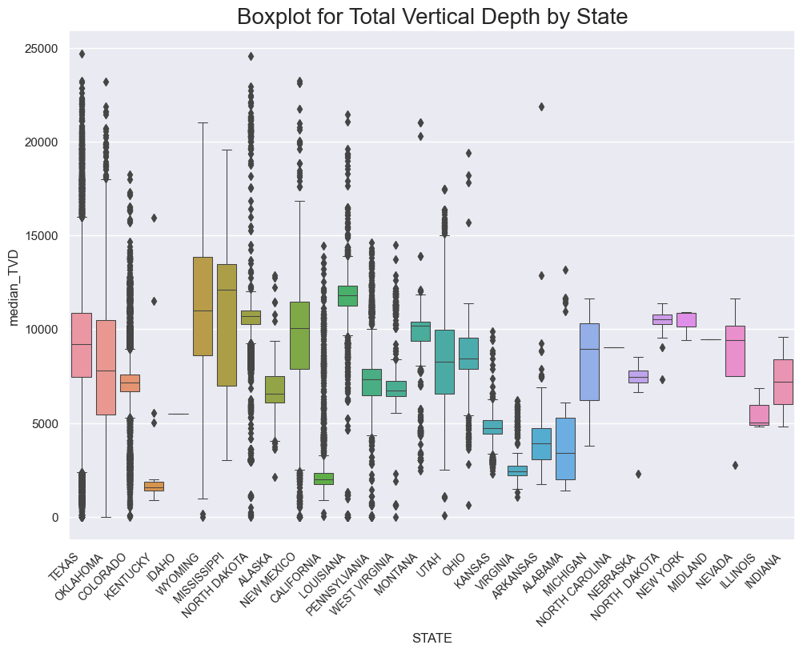
Comparing state by state Total Base Water Volume numbers, Louisiana had the highest Median Total Base Water Volume at over 15 million gallons per well. Other states with a Median Total Base Water Volume above 10 million gallons were New Mexico, West Virginia, Ohio, and New York. Although Texas has a Median water number below 10 million gallons per well, it has the greatest number of wells that consume base water of more than 40 million gallons, followed by Ohio and Pennsylvania. In an interesting article by the New York Times, ‘Monster Fracks’ Are Getting Far Bigger. And Far Thirstier, on September 25, 2023, refers to these fracking projects consuming enormous amounts of water as “Monster fracks”. The article indicates that these “monster fracks” barely existed a decade ago, but now became the industry norm. The article also states that the “monster fracks” constitute almost two out of three fracking wells in Texas nowadays.
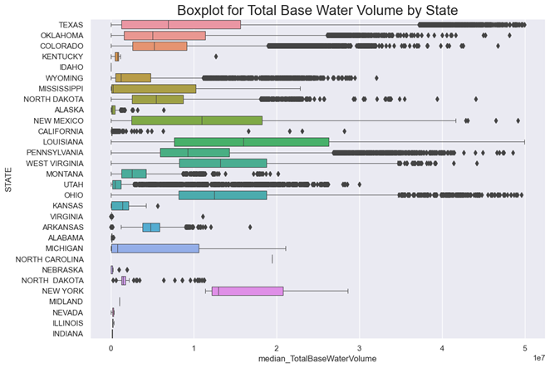
The correlation analysis shows that there is a positive correlation between the two variables (0.26). The simple linear regression analysis using the Ordinary Least Squares (OLS) method shows that the Total Vertical Depth of a well is a significant factor to explain the Total Base Water Volume consumed by a well. The deeper wells tend to be associated with high level of water consumption. We also took the Z-scores of both variables to standardize the two attributes.
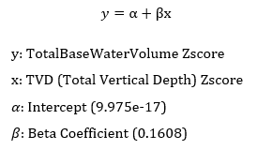
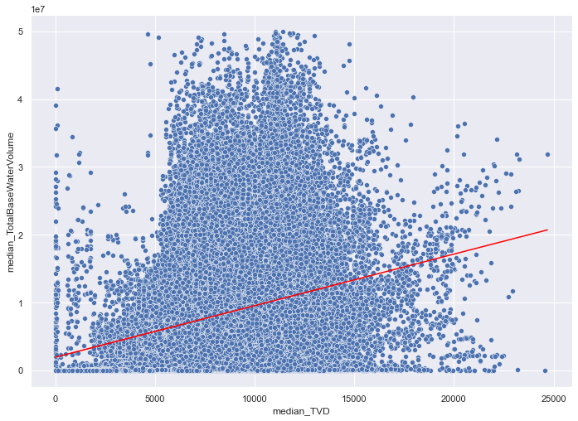
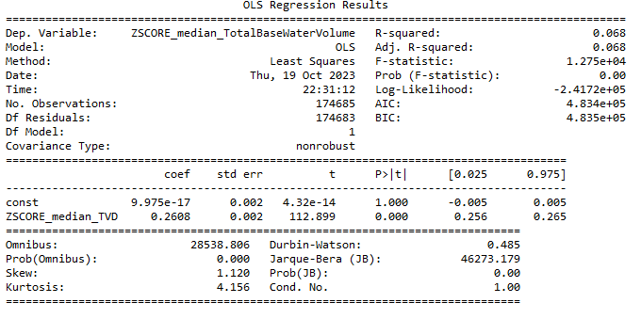

- Results from Natural Language Processing and Machine Learning
In addition to the simple regression analysis, we also wanted to run multiple regression analysis to use multiple independent variables in regression. The registry database also provides two additional attributes, PercentHighAdditive and PercentHFjob, that we are going to try to use. In addition, we wanted to include attributes such as ingredients used in fracking fluids as well as purposes for additives. However, the detailed registry table with these data elements are stored in free text forms and has over 6.1 million rows. It is difficult to use simple queries to identify the keywords. Therefore, we researched and tested several Natural Language Process techniques (NLP) in Python such as TF-IDF and NLTK to extract keywords from the data fields. For example, NLTK word_tokenize function can split the text strings into word tokens, and then the NLTK FreqDist function can count the occurrence of certain keywords being used. After the keywords frequencies are calculated, we decided to select the top 40 common keywords for the purposes of additives and ingredients used. The relationships between these key elements and the total base water volume consumed will be examined later. Here are some keyword frequency analyses using NLTK.
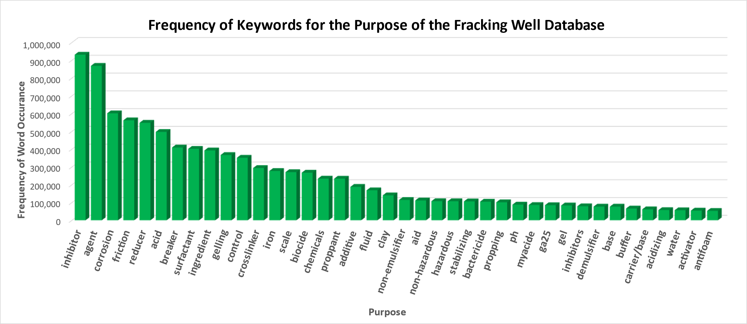
The above chart shows the top 40 keywords that have the largest occurrences in the Purpose for additives field in the database. We can see the most frequent words are such as Proppant, Carrier Base Fluid, Friction Reducer, Biocide, Breaker, Scale Inhibitor, Corrosion Inhibitor, Cross Linker, Surfactant, Iron Control, Gelling Agent, Acid, Solvent, Clay Control, Acidizing, etc.
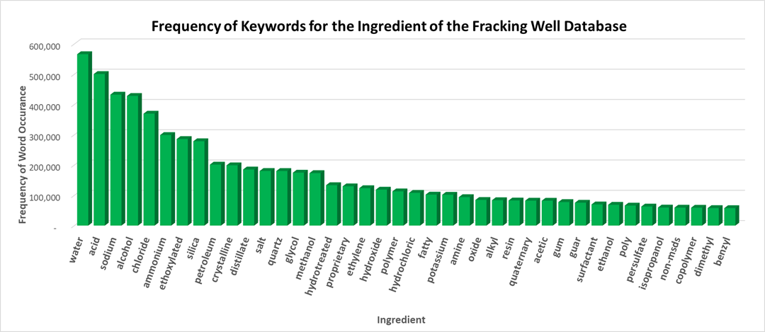
We did a similar analysis to look at the ingredients in fracking fluids for the drilling jobs and additives. The ingredients that are used most often are water, acid, sodium, alcohol, chloride, ammonium, ethoxylated, silica, petroleum, crystalline, distillate, salt, quartz, glycol, methanol, etc. Later in this paper we will evaluate the relationships between these ingredients and the total base water volume consumed in a well. We also created a WordCloud Map to show the frequency of the ingredients. The map has Water in the largest font centered in the middle, clearly indicating that Water is used excessively in fracking and it alerts us to take precaution in the fracking techniques which may bring negative implications to drinking water and natural environment.
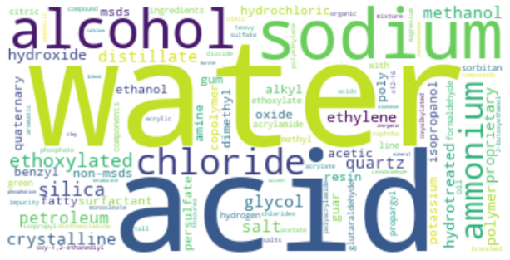
With the keywords for ingredients and Promises being identified using NLP for each entity (Firm/Well/job), we then picked the top keywords and transformed them into a list of dummy variables. For example, if a well uses “ammonium” as an ingredient, then the value of the dummy variable IN_ammonium_ind for this well would be 1. The wells that do not use “ammonium” would have a value of 0 for the dummy variable IN_ammonium_ind. After the transformation, we can use these elements in regressions as well as in feeding them into machine learning models.
With dummy variables created, we first created correlation maps, and then built multiple linear regression models to examine the relationships between the Total Base Water Volume vs. a list of other factors. The following table shows the correlations with the Total Base Water Volume. As we evaluated earlier, there is a positive correlation between the vertical depth of the well and the base water volume consumed by the well. The deeper the well, the more base water is consumed. The following table shows that positive correlations with the base water consumed exist between acid, alcohol, ethoxylated, silica, petroleum, and crystalline. Negative correlations with the base water consumption exist between Percent High Additive, Sodium, salt, quartz, glycol and methanol.
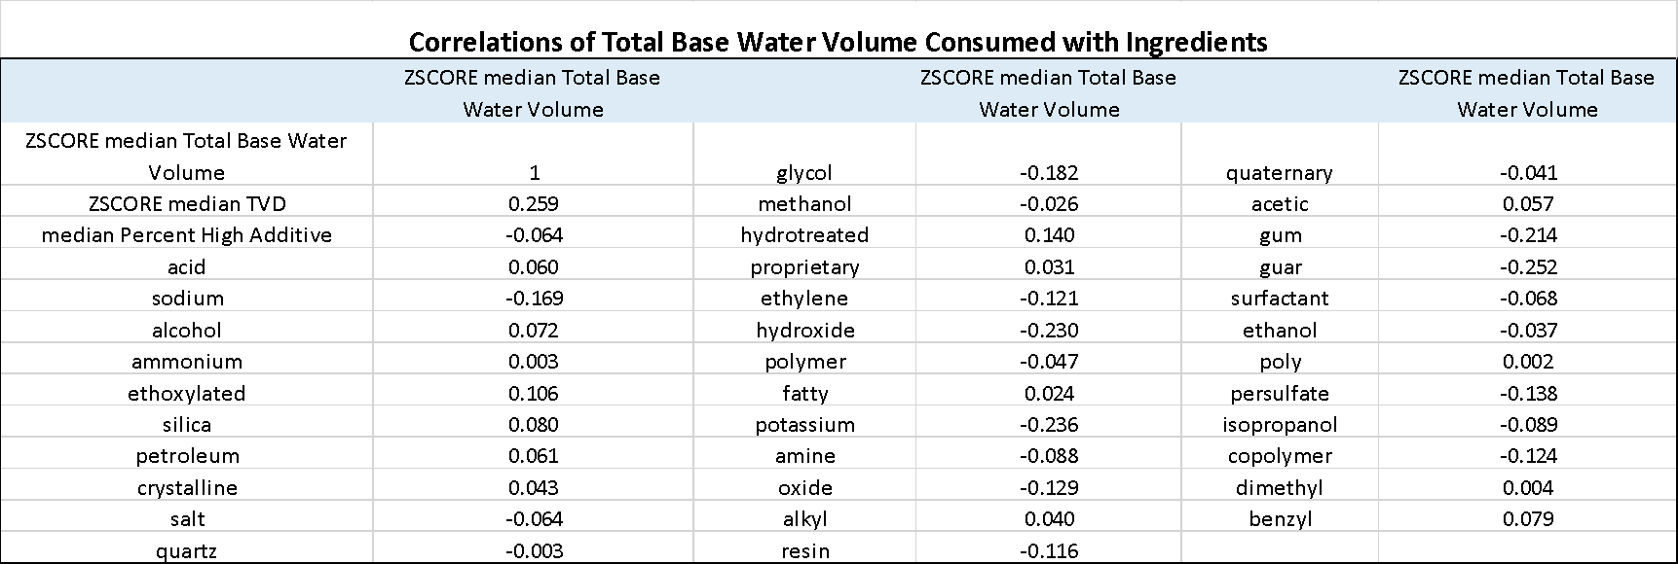
Next we ran a multiple linear regression model. Since there seem to be multicollinearity issues between Ingredients used and purpose of additives, we decided only to include the ingredients in the model. We also ran the regression model a few times, each time dropping the independent variables with coefficient T-value less than 2. Here are the remaining factors. The F-statistics equal to 1281, which indicates that the model as a whole can explain the level of base water volume consumed. However, a further look into each of the factors will help to enhance the model and understand the factor’s impact on the total base water consumed.

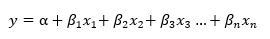
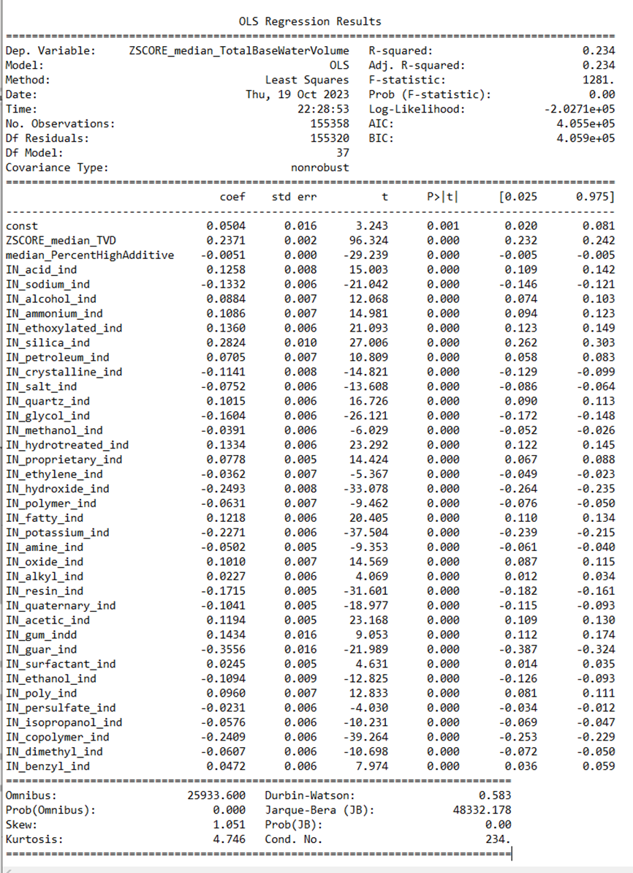
We then ran an unsupervised cluster analysis by feeding in all the variables into a clustering algorithm. Since we have both numerical variables and categorical variables in the models, we use a clustering algorithm called KPrototypes model that incorporates KMeans model for numerical variables and KMode for categorical data. The first part of the equation below, 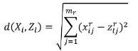, uses Euclidean distance to measure similarities for numerical variables. The second part of the following equation, 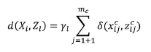 is used to measure similarities for categorical variables. KPrototypes algorithm enables us to feed both numerical and categorical variables into the clustering model.
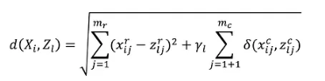
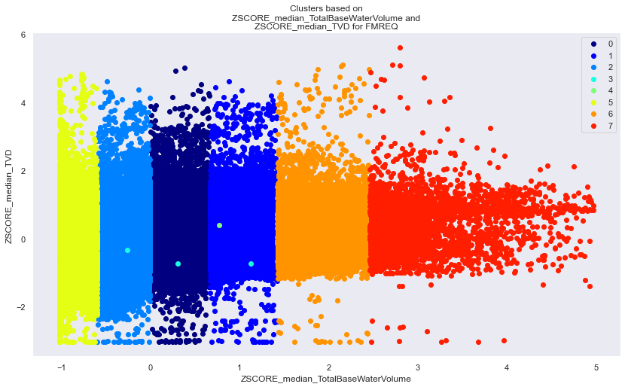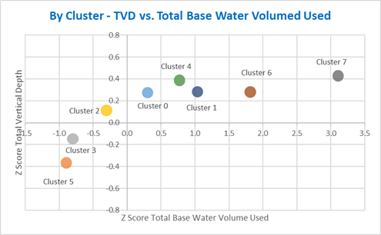
We decided to set K=8 to ask the Clustering algorithm to create 8 clusters based on all the factors fed into the model. The left chart above shows the 8 clusters in a two-dimensional view, Water Volume vs. TVD. The right graph shows the centroid of each cluster, also in a two-dimensional view. The actual clusters are formed using all the factors which are difficult to visualize.
In addition to evaluating the factors that affect the base water volume consumption per well, we also want to evaluate what may be the important factors to affect water quality and cause water contamination in areas close to the fracking wells. We tried to look for the violation reporting database with records on the firms that have had reported cases of water quality violations. Unfortunately, such data is not easily available to the general public free of cost. Therefore, we identified several papers and reports with information on water contamination cases and used these cases as training data. We then translated the data into machine learning ready data format by creating a Boolean variable, where 1 means the firm had reported violation in water contamination, and 0 means no reported water contamination cases. The dataset from the FracFocus database is then joined with this Boolean variable. The goal is to build a machine learning model that can use the registry data provided by FracFocus to predict the likelihood that an operating firm will cause a water contamination incident. We tested both the Logistic Regression model and Random Forest model, and the Random Forest model generated better results in this case. Also we separated data into two buckets, one, training dataset used to build the model and the other, testing dataset used to test the accuracy of the model. The Confusion Matrix and Classification Report below show the accuracy of the model. When testing the model using a test dataset, The Confusion Matrix on the left below shows that the model had 31 cases of correct prediction out of a total of 42 cases, 16 cases of true positives and 15 cases of true negatives. The model had 11 cases of incorrect prediction, 6 cases of false negative and 5 cases of false positive.
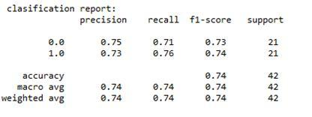
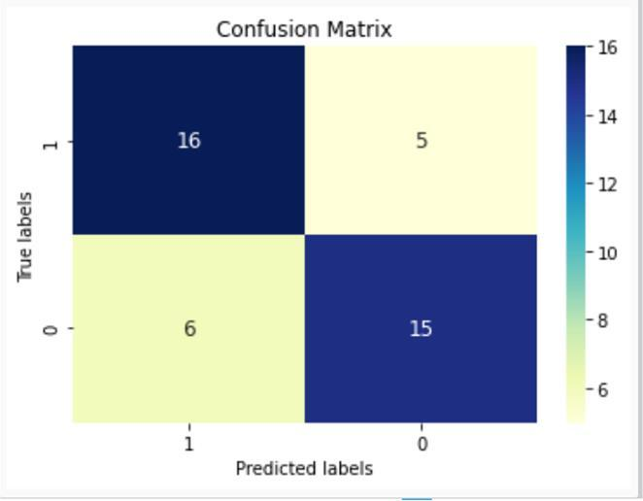
The accuracy of the Random Forest model needs to be enhanced. However, since we only have a limited number of violation cases available to use as a training dataset. Machine learning relies heavily on learning from prior knowledge, in order to improve the accuracy of this predictive model to identify firms with water contamination probabilities, we need to explore more data sources for further model building needs.
Conclusions
In conclusion, while fracking has brought significant economic benefits to the United States through providing abundant energy for industrial and personal consumptions, it has undoubtedly created a significant environmental and climate threat from its excessive and surging water consumption and water contamination from chemical ingredients used in fracking fluids. We hope this research using the up-to-date data on fracking wells nationwide can provide people with some insights on the water consumption and its correlating factors in fracking wells. We hope to enhance the predictive model for identifying potential problem wells to empower the regulators and policy makers to take proactive actions. To protect our precious underground water resources and natural environment, we should also advocate for a responsible use of water resources and seek alternative and sustainable energy resources.

Acknowledgements
I sincerely thank Professor Magaly Koch from Boston University for teaching me the research methodologies and for stimulating my interests in environmental studies.
I sincerely thank Professor Koch and the Teaching Assistant Diana Tosato for helping me through the process of brainstorming the research topics, identifying literature review sources, discussing data analytics methods, and helping me edit the paper.
Bibliography
- The costs of fracking. Environment America Research & Policy Center. (2022, September 29). https://environmentamerica.org/center/resources/the-costs-of-fracking/
- Denchak, M. (2019, April 19). Fracking 101. Be a Force for the Future. https://www.nrdc.org/stories/fracking-101#work
- Drilling and the hydraulic fracturing (fracking) process. UKOOG. (n.d.). https://www.ukoog.org.uk/onshore-extraction/drilling-process
- Haley Greenyer, "Hydraulic Fracturing, What is it?," https://hydrauliceconomics.weebly.com/, https://hydrauliceconomics.weebly.com/what-is-fracking.html.
- Endocrine Society. (2020, March 31). Fracking chemical may interfere with male sex hormone receptor. https://www.endocrine.org/news-and-advocacy/news-room/2020/fracking-chemical-may-interfere-with-male-sex-hormone-receptor
- Fontenot, B. E., Hunt, L. R., Hildenbrand, Z. L., Carlton Jr., D. D., Oka, H., Walton, J. L., Hopkins, D., Osorio, A., Bjorndal, B., Hu, Q. H., & Schug, K. A. (2013). An evaluation of water quality in private drinking water wells near natural gas extraction sites in the Barnett Shale Formation. Environmental Science &amp; Technology, 47(17), 10032–10040. https://doi.org/10.1021/es4011724
- Hildenbrand, Z. L., Carlton, D. D., Fontenot, B. E., Meik, J. M., Walton, J. L., Taylor, J. T., Thacker, J. B., Korlie, S., Shelor, C. P., Henderson, D., Kadjo, A. F., Roelke, C. E., Hudak, P. F., Burton, T., Rifai, H. S., & Schug, K. A. (2015). A comprehensive analysis of groundwater quality in the Barnett Shale Region. Environmental Science &amp; Technology, 49(13), 8254–8262. https://doi.org/10.1021/acs.est.5b01526
- Hydraulic fracturing. Energy API. (n.d.-a). https://www.api.org/oil-and-natural-gas/wells-to-consumer/exploration-and-production/hydraulic-fracturing#sort=date%20descending
- Hydraulic fracturing. Energy API. (n.d.-b). https://www.api.org/news-policy-and-issues/hydraulic-fracturing
- Kondash, A. J., Lauer, N. E., & Vengosh, A. (2018). The intensification of the water footprint of hydraulic fracturing. Science Advances, 4(8). https://doi.org/10.1126/sciadv.aar5982
- Landis, J. D., Sharma, M., & Renock, D. (2018). Rapid desorption of radium isotopes from black shale during hydraulic fracturing. 2. A model reconciling radium extraction with marcellus wastewater production. Chemical Geology, 500, 194–206. https://doi.org/10.1016/j.chemgeo.2018.08.001
- Landis, J. D., Sharma, M., Renock, D., & Niu, D. (2018). Rapid desorption of radium isotopes from black shale during hydraulic fracturing. 1. source phases that control the release of Ra from marcellus shale. Chemical Geology, 496, 1–13. https://doi.org/10.1016/j.chemgeo.2018.06.013
- Osborn, S. G., Vengosh, A., Warner, N. R., & Jackson, R. B. (2011). Methane contamination of drinking water accompanying gas-well drilling and hydraulic fracturing. Proceedings of the National Academy of Sciences, 108(20), 8172–8176. https://doi.org/10.1073/pnas.1100682108
- Quinones, L., DeShon, H. R., Jeong, S., Ogwari, P., Sufri, O., Holt, M. M., & Kwong, K. B. (2019). Tracking induced seismicity in the Fort Worth Basin: A summary of the 2008–2018 north texas earthquake study catalog. Bulletin of the Seismological Society of America, 109(4), 1203–1216. https://doi.org/10.1785/0120190057
- Solutions to address water scarcity in the U.S. The Nature Conservancy. (2020, February 13). https://www.nature.org/en-us/what-we-do/our-priorities/provide-food-and-water-sustainably/food-and-water-stories/solutions-address-water-scarcity-us/
- Srebotnjak, T., & Rotkin-Ellman, M. (2014, December). NRDC: Air pollution from hydraulic fracturing threatens public health ... Fracking Fumes: Air Pollution from Hydraulic Fracturing Threatens Public Health and Communities. https://www.nrdc.org/sites/default/files/fracking-air-pollution-IB.pdf
- Frac Focus Chemical Disclosure Registry. "The national hydraulic fracturing chemical disclosure registry." Last modified October 12, 2023. https://fracfocus.org/data-download.
- Huang, Zhexue. "Extensions to the k-Means Algorithm for Clustering Large Data Sets with Categorical Values." Data Mining and Knowledge Discovery 2 (1998): 283-304.
- Kelso, Matt. "VIOLATIONS PER WELL AMONG PA OPERATORS." FracTracker.org. Last modified October 29, 2013. https://www.fractracker.org/2013/10/violations-per-well-among-pa-operators/.
- NRDC (the Natural Resources Defense Council). Fracking's Most Wanted: Lifting the Veil on Oil and Gas Company Spills and Violations. Report no. ip:15-01-a. April 2015. https://www.nrdc.org/sites/default/files/fracking-company-violations-IP.pdf.
- Stone, Les. "Fracking's Environmental Impacts: Water." https://www.greenpeace.org/. https://www.greenpeace.org/usa/fighting-climate-chaos/issues/fracking/environmental-impacts-water/#:~:text=Contamination%20of%20Water%20Wells%20and,water%20for%20many%20rural%20communities.
- Tabuchi, Hiroko, and Blacki Migliozzi. "'Monster Fracks' Are Getting Far Bigger. And Far Thirstier." The New York Times. Accessed September 25, 2023. https://www.nytimes.com/interactive/2023/09/25/climate/fracking-oil-gas-wells-water.html.
- Bondu, Raphaël, Wolfram Kloppmann, Maria O. Naumenko-Dèzes, Pauline Humez, and Bernhard Mayer. "Potential Impacts of Shale Gas Development on Inorganic Groundwater Chemistry: Implications for Environmental Baseline Assessment in Shallow Aquifers." Environmental Science & Technology 55, no. 14 (2021): 9657-71. https://doi.org/10.1021/acs.est.1c01172.
- Clark, Cassandra J., Nicholaus P. Johnson, Mario Soriano, Joshua L. Warren, Keli M. Sorrentino, Nina S. Kadan-Lottick, James E. Saiers, Xiaomei Ma, and Nicole C. Deziel. "Unconventional Oil and Gas Development Exposure and Risk of Childhood Acute Lymphoblastic Leukemia: A Case–Control Study in Pennsylvania, 2009–2017." Environmental Health Perspectives 130, no. 8 (2022). https://doi.org/10.1289/ehp11092.
- Cook, Margaret, Karen L. Huber, and Michael E. Webber. "Who Regulates It? Water Policy and Hydraulic Fracturing in Texas." Texas Water Journal 6, no. 1 (2015): 45-63. https://doi.org/10.21423/twj.v6i1.7021.
- Darrah, Thomas H., Avner Vengosh, Robert B. Jackson, Nathaniel R. Warner, and Robert J. Poreda. "Noble Gases Identify the Mechanisms of Fugitive Gas Contamination in Drinking-water Wells Overlying the Marcellus and Barnett Shales." Proceedings of the National Academy of Sciences 111, no. 39 (2014): 14076-81. https://doi.org/10.1073/pnas.1322107111.
- Davis, Charles. "Fracking and Environmental Protection: An Analysis of U.S. State Policies." The Extractive Industries and Society 4, no. 1 (2017): 63-68. https://doi.org/10.1016/j.exis.2016.12.009.
- DiGiulio, Dominic C., and Robert B. Jackson. "Impact to Underground Sources of Drinking Water and Domestic Wells from Production Well Stimulation and Completion Practices in the Pavillion, Wyoming, Field." Environmental Science & Technology 50, no. 8 (2016): 4524-36. https://doi.org/10.1021/acs.est.5b04970.
- Eitrheim, Eric S., Dustin May, Tori Z. Forbes, and Andrew W. Nelson. "Disequilibrium of Naturally Occurring Radioactive Materials (NORM) in Drill Cuttings from a Horizontal Drilling Operation." Environmental Science & Technology Letters 3, no. 12 (2016): 425-29. https://doi.org/10.1021/acs.estlett.6b00439.
- Emmons, Ronald V., Tiffany Liden, Kevin A. Schug, and Emanuela Gionfriddo. "Optimization of Thin Film Solid Phase Microextraction and Data Deconvolution Methods for Accurate Characterization of Organic Compounds in Produced Water." Journal of Separation Science 43, nos. 9-10 (2020): 1915-24. https://doi.org/10.1002/jssc.201901330.
- Fuchs, Samantha, GIS in Water Resources, and David Maidment, Dr. Hydraulic Fracturing in the Barnett Shale. https://www.caee.utexas.edu/prof/maidment/giswr2015/TermProject/Fuchs.pdf.
- Gassiat, Claire, Tom Gleeson, René Lefebvre, and Jeffrey McKenzie. "Hydraulic Fracturing in Faulted Sedimentary Basins: Numerical Simulation of Potential Contamination of Shallow Aquifers over Long Time Scales." Water Resources Research 49, no. 12 (2013): 8310-27. https://doi.org/10.1002/2013wr014287.
- Heilweil, Victor M., Paul L. Grieve, Scott A. Hynek, Susan L. Brantley, D. Kip Solomon, and Dennis W. Risser. "Stream Measurements Locate Thermogenic Methane Fluxes in Groundwater Discharge in an Area of Shale-Gas Development." Environmental Science & Technology 49, no. 7 (2015): 4057-65. https://doi.org/10.1021/es503882b.
- Hildenbrand, Zacariah L., Doug D. Carlton, Brian E. Fontenot, Jesse M. Meik, Jayme L. Walton, Jonathan B. Thacker, Stephanie Korlie, C. Phillip Shelor, Akinde F. Kadjo, Adelaide Clark, Sascha Usenko, Jason S. Hamilton, Phillip M. Mach, Guido F. Verbeck, Paul Hudak, and Kevin A. Schug. "Temporal Variation in Groundwater Quality in the Permian Basin of Texas, a Region of Increasing Unconventional Oil and Gas Development." Science of the Total Environment 562 (August 2016): 906-13. https://doi.org/10.1016/j.scitotenv.2016.04.144.
- Hitaj, Claudia, Andrew J. Boslett, and Jeremy G. Weber. "Fracking, Farming, and Water." Energy Policy 146 (November 2020): 111799. https://doi.org/10.1016/j.enpol.2020.111799.
- Jackson, Robert B., Ella R. Lowry, Amy Pickle, Mary Kang, Dominic DiGiulio, and Kaiguang Zhao. "The Depths of Hydraulic Fracturing and Accompanying Water Use across the United States." Environmental Science & Technology 49, no. 15 (2015): 8969-76. https://doi.org/10.1021/acs.est.5b01228.
- Kuwayama, Yusuke, Sheila Olmstead, and Alan Krupnick. "Water Quality and Quantity Impacts of Hydraulic Fracturing." Current Sustainable/Renewable Energy Reports 2, no. 1 (2015): 17-24. https://doi.org/10.1007/s40518-014-0023-4.
- Office of Research and Development, EPA. "EPA's Study of Hydraulic Fracturing for Oil and Gas and Its Potential Impact on Drinking Water Resources." EPA - United States Environmental Protection Agency. Last modified December 2016. https://www.epa.gov/hfstudy.
- "The Potential Impacts of Hydraulic Fracturing on Agriculture." European Journal of Sustainable Development 3, no. 3 (2014): 63-72. https://doi.org/10.14207/ejsd.2014.v3n3p63.
- Quinones, Louis, Heather R. DeShon, SeongJu Jeong, Paul Ogwari, Oner Sufri, Monique M. Holt, and Kevin B. Kwong. "Tracking Induced Seismicity in the Fort worth Basin: A Summary of the 2008–2018 North Texas Earthquake Study Catalog." Bulletin of the Seismological Society of America 109, no. 4 (2019): 1203-16. https://doi.org/10.1785/0120190057.
- Renock, Devon, Joshua D. Landis, and Mukul Sharma. "Reductive Weathering of Black Shale and Release of Barium during Hydraulic Fracturing." Applied Geochemistry 65 (February 2016): 73-86. https://doi.org/10.1016/j.apgeochem.2015.11.001.
- Rodriguez, Jose, Joonghyeok Heo, and Kee Han Kim. "The Impact of Hydraulic Fracturing on Groundwater Quality in the Permian Basin, West Texas, USA." Water 12, no. 3 (2020): 796. https://doi.org/10.3390/w12030796.
- Rogers, Jessica D., Troy L. Burke, Stephen G. Osborn, and Joseph N. Ryan. "A Framework for Identifying Organic Compounds of Concern in Hydraulic Fracturing Fluids Based on Their Mobility and Persistence in Groundwater." Environmental Science & Technology Letters 2, no. 6 (2015): 158-64. https://doi.org/10.1021/acs.estlett.5b00090.
- Soriano, Mario A., Nicole C. Deziel, and James E. Saiers. "Regional Scale Assessment of Shallow Groundwater Vulnerability to Contamination from Unconventional Hydrocarbon Extraction." Environmental Science & Technology 56, no. 17 (2022): 12126-36. https://doi.org/10.1021/acs.est.2c00470.
- STANFORD UNIVERSITY. "Does living near an oil or natural gas well affect your drinking water?" EurekAlert! Last modified February 14, 2016. https://www.eurekalert.org/news-releases/803327.
- Zhai, Guang, Manoochehr Shirzaei, and Michael Manga. "Widespread Deep Seismicity in the Delaware Basin, Texas, Is Mainly Driven by Shallow Wastewater Injection." Proceedings of the National Academy of Sciences 118, no. 20 (2021). https://doi.org/10.1073/pnas.2102338118.

Frac Focus Chemical Disclosure Registry, "The national hydraulic fracturing chemical disclosure registry.," last modified October 12, 2023, https://fracfocus.org/data-download.
“Hydraulic fracturing. Independent Petroleum Association of America. (1970, January 27). https://www.ipaa.org/fracking/ .”
Denchak, M. (2019, April 19). Fracking 101. Be a Force for the Future. https://www.nrdc.org/stories/fracking-101#work
Drilling and the hydraulic fracturing (fracking) process. UKOOG. (n.d.). https://www.ukoog.org.uk/onshore-extraction/drilling-process
Haley Greenyer, "Hydraulic Fracturing, What is it?," https://hydrauliceconomics.weebly.com/, https://hydrauliceconomics.weebly.com/what-is-fracking.html.
Office of Research and Development, EPA, "EPA's Study of Hydraulic Fracturing for Oil and Gas and Its Potential Impact on Drinking Water Resources," EPA - United States Environmental Protection Agency, last modified December 2016, https://www.epa.gov/hfstudy.
Hydraulic fracturing. Independent Petroleum Association of America. (1970, January 27). https://www.ipaa.org/fracking/
Hydraulic fracturing. Energy API. (n.d.). https://www.api.org/news-policy-and-issues/hydraulic-fracturing
The costs of fracking. Environment America Research & Policy Center. (2022, September 29). https://environmentamerica.org/center/resources/the-costs-of-fracking/
Quinones, L., DeShon, H. R., Jeong, S., Ogwari, P., Sufri, O., Holt, M. M., & Kwong, K. B. (2019). Tracking induced seismicity in the Fort Worth Basin: A summary of the 2008–2018 north texas earthquake study catalog. Bulletin of the Seismological Society of America, 109(4), 1203–1216. https://doi.org/10.1785/0120190057
Srebotnjak, T., & Rotkin-Ellman, M. (2014, December). NRDC: Air pollution from hydraulic fracturing threatens public health ... Fracking Fumes: Air Pollution from Hydraulic Fracturing Threatens Public Health and Communities. https://www.nrdc.org/sites/default/files/fracking-air-pollution-IB.pdf
Endocrine Society. (2020, March 31). Fracking chemical may interfere with male sex hormone receptor. https://www.endocrine.org/news-and-advocacy/news-room/2020/fracking-chemical-may-interfere-with-male-sex-hormone-receptor
Landis, J. D., Sharma, M., Renock, D., & Niu, D. (2018). Rapid desorption of radium isotopes from black shale during hydraulic fracturing. 1. source phases that control the release of Ra from marcellus shale. Chemical Geology, 496, 1–13. https://doi.org/10.1016/j.chemgeo.2018.06.013
Frac Focus Chemical Disclosure Registry, "The national hydraulic fracturing chemical disclosure registry.," last modified October 12, 2023, https://fracfocus.org/data-download.
Matt Kelso, "VIOLATIONS PER WELL AMONG PA OPERATORS," FracTracker.org, last modified October 29, 2013, https://www.fractracker.org/2013/10/violations-per-well-among-pa-operators/.
Les Stone, "Fracking's Environmental Impacts: Water," https://www.greenpeace.org/, https://www.greenpeace.org/usa/fighting-climate-chaos/issues/fracking/environmental-impacts-water/#:~:text=Contamination%20of%20Water%20Wells%20and,water%20for%20many%20rural%20communities.
NRDC (the Natural Resources Defense Council), Fracking's Most Wanted: Lifting the Veil on Oil and Gas Company Spills and Violations, report no. ip:15-01-a, [Page #], April 2015, https://www.nrdc.org/sites/default/files/fracking-company-violations-IP.pdf.
Osborn, S. G., Vengosh, A., Warner, N. R., & Jackson, R. B. (2011). Methane contamination of drinking water accompanying gas-well drilling and hydraulic fracturing. Proceedings of the National Academy of Sciences, 108(20), 8172–8176. https://doi.org/10.1073/pnas.1100682108
Osborn, S. G., Vengosh, A., Warner, N. R., & Jackson, R. B. (2011). Methane contamination of drinking water accompanying gas-well drilling and hydraulic fracturing. Proceedings of the National Academy of Sciences, 108(20), 8172–8176. https://doi.org/10.1073/pnas.1100682108
Hildenbrand, Z. L., Carlton, D. D., Fontenot, B. E., Meik, J. M., Walton, J. L., Taylor, J. T., Thacker, J. B., Korlie, S., Shelor, C. P., Henderson, D., Kadjo, A. F., Roelke, C. E., Hudak, P. F., Burton, T., Rifai, H. S., & Schug, K. A. (2015). A comprehensive analysis of groundwater quality in the Barnett Shale Region. Environmental Science &amp; Technology, 49(13), 8254–8262. https://doi.org/10.1021/acs.est.5b01526
Fontenot, B. E., Hunt, L. R., Hildenbrand, Z. L., Carlton Jr., D. D., Oka, H., Walton, J. L., Hopkins, D., Osorio, A., Bjorndal, B., Hu, Q. H., & Schug, K. A. (2013). An evaluation of water quality in private drinking water wells near natural gas extraction sites in the Barnett Shale Formation. Environmental Science &amp; Technology, 47(17), 10032–10040. https://doi.org/10.1021/es4011724 .
Landis, J. D., Sharma, M., Renock, D., & Niu, D. (2018). Rapid desorption of radium isotopes from black shale during hydraulic fracturing. 1. source phases that control the release of Ra from marcellus shale. Chemical Geology, 496, 1–13. https://doi.org/10.1016/j.chemgeo.2018.06.013
Landis, J. D., Sharma, M., & Renock, D. (2018). Rapid desorption of radium isotopes from black shale during hydraulic fracturing. 2. A model reconciling radium extraction with marcellus wastewater production. Chemical Geology, 500, 194–206. https://doi.org/10.1016/j.chemgeo.2018.08.001
Kondash, A. J., Lauer, N. E., & Vengosh, A. (2018). The intensification of the water footprint of hydraulic fracturing. Science Advances, 4(8). https://doi.org/10.1126/sciadv.aar5982
U.S. EPA. Hydraulic Fracturing for Oil and Gas: Impacts from the Hydraulic Fracturing Water Cycle on Drinking Water Resources in the United States (Final Report). U.S. Environmental Protection Agency, Washington, DC, EPA/600/R-16/236F, 2016.
“Solutions to address water scarcity in the U.S. The Nature Conservancy. (2020, February 13). https://www.nature.org/en-us/what-we-do/our-priorities/provide-food-and-water-sustainably/food-and-water-stories/solutions-address-water-scarcity-us/
Hiroko Tabuchi and Blacki Migliozzi, "'Monster Fracks' Are Getting Far Bigger. And Far Thirstier.," The New York Times, [Page #], accessed September 25, 2023, https://www.nytimes.com/interactive/2023/09/25/climate/fracking-oil-gas-wells-water.html.
Zhexue Huang, "Extensions to the k-Means Algorithm for Clustering Large Data Sets with Categorical Values," Data Mining and Knowledge Discovery 2 (1998): [Page #].

