A Novel Frontier in EBV Vaccine Research: mRNA-Based Immunization with gp350, gp42, and gL Glycoproteins

Hailey Xi

Introduction

Currently, of all known human viruses, only approximately 10% have a working vaccine (Forni et al., 2022; Office of Infectious Disease and HIV/AIDS Policy, 2022). Messenger RNA (mRNA) vaccines have emerged as a groundbreaking innovation in the field of vaccinology—most recently with the Nobel Prize awarded to two scientists who made pivotal strides in mRNA synthesis—offering a promising approach to combat a wide range of infectious diseases, including those caused by complex pathogens like the Epstein-Barr virus (EBV). mRNA vaccines like Moderna and Pfizer BioNTech make up the majority of vaccines distributed in the wake of the SARS-CoV-2 pandemic, with a campaign resulting in 13.51 billion doses administered as of August 5th, 2023 (Mathieu et al. 2023). The development of mRNA vaccines represents a paradigm shift in how immunization against infectious diseases is approached. Unlike traditional vaccines that rely on weakened or inactivated pathogens, mRNA vaccines utilize a revolutionary concept. In a much more streamlined and less costly development process, they provide the body with genetic instructions in the form of synthetic mRNA, enabling cells to produce harmless pieces of the target pathogen (Pardi et al., 2018). This prompts a robust and targeted immune response, harnessing the body’s own cellular machinery and effectively priming the body to recognize and fight the pathogen if encountered. The mRNA encoding this protein is encapsulated in lipid nanoparticles, facilitating its delivery into cells. Upon translation of the mRNA, the produced protein is displayed on the cell's surface, triggering an immune response. mRNA vaccines have shown remarkable adaptability, making them suitable for addressing a broad spectrum of infectious diseases, from viral infections to bacterial pathogens.

Epstein-Barr virus (EBV), a member of the herpesvirus family, is one of the most widespread human viruses—infecting 95% of adults worldwide—yet it has no clinically approved vaccine (Cohen, 2000). EBV has a double-stranded DNA (dsDNA) structure, with several main parts making up its 170 nanometers (nm): an outer lipid bilayer envelope, a central core, and an inner, irregularly shaped middle compartment (Cai et al.,2021). EBV infections are usually asymptomatic or present as mild illnesses, but this virus is also implicated in more complex and serious medical conditions. It has evolved sophisticated mechanisms to evade the immune system, persist in the host, and establish latent infections—where the virus lies dormant in host cells. With four latency phases, the virus can shut down certain immunogenic genes, allowing long-term persistence in host cells without detection. These unique characteristics make vaccine development tricky. EBV’s adaptability and complexity contribute to its diverse clinical manifestations, ranging from infectious mononucleosis (commonly known as mono) to its involvement in more severe disorders. One of the most intriguing aspects of EBV is its association with various types of cancer, including Burkitt lymphoma, nasopharyngeal carcinoma, and Hodgkin lymphoma; the World Health Organization (WHO) has categorized EBV as a class I oncogenic virus due to its role as a significant global health concern, attributed directly to roughly 200,000 newly diagnosed tumors each year across the world. This amounts to 1.5% of human cancer globally (Farrell, 2019). EBV has a unique ability to promote uncontrolled cell growth by altering host-cell DNA. As recent evidence surfaces, EBV has also been implicated in autoimmune diseases, including multiple sclerosis (Bjornevik et al., 2022). Researchers are actively investigating the mechanisms underlying these connections, with the hope of uncovering potential therapeutic interventions. Though several attempts at clinical trials for EBV vaccines have been recorded, none have received approval and many face issues in efficacy or adjuvant selection (Cai et al., 2021). This is where newer mRNA vaccines come into play.

Methods

Table 1. Overview of candidate genes
Candidate Gene | Product | Genbank ID | Properties
BLLF1 | gp350 | QCG99665.1 | The most abundantly expressed surface glycoprotein during both phases (most notably lytic) first viral attachment protein.
BKRF2 | gL | UQK62613.1 | Non-membrane bound part of the gH/gL glycoprotein complex. Essential for viral entry into the host cell via fusion of viral and plasma membranes.
BZLF2 | gp42 | QZL09798.1 | Contributes to infection of B-cells (primary EBV reservoir) and acts as a tropism switch. Role in immune evasion by blocking T-cell receptors after fused to the gH/gL complex ensures the virus is undetected.

Engineering the mRNA Vaccines

For each candidate protein, the amino acid sequences of EBV proteins gp350 (product of gene BLLF1), gp42 (product of gene BZLF2), and gL (product of gene BKRF2) were obtained from the NCBI Virus database in FASTA format. The same procedure was repeated for the SARS-CoV-2 surface glycoprotein to predict the signal sequence and transmembrane domain.

Then, the protein structure prediction software InterProScan version 96.0 was utilized to identify signal sequences and transmembrane domains in the amino acid sequences.
The Moderna mRNA vaccine sequence was utilized as a model for designing the mRNA vaccines. To analyze the mRNA sequence of the Moderna vaccine model, SnapGene version 7.0.2 was employed to identify the locations of the 5' UTR, 3' UTR, and polyA tail in the model based on the sequence.

Next, the signal sequence and transmembrane domain were located within the SARS-CoV-2 Spike protein (e.g., obtained from InterProScan) and inserted into the respective N-terminus and C-terminus of the candidate protein's amino acid sequence where necessary. Lastly, the other elements of the mRNA vaccine model were inserted into the sequence. The design of the mRNA vaccine sequences for each candidate protein incorporated the following elements in order from 5' to 3':

- 5' UTR sequence from the Moderna mRNA vaccine model
- Open reading frame (ORF) of the candidate vaccine protein, which includes the engineered signal sequence and transmembrane domain, if applicable.
- 3' UTR sequence from the Moderna mRNA vaccine model
- Poly(A) tail

Outlined are the design processes for each candidate protein:

Envelope Glycoprotein 350

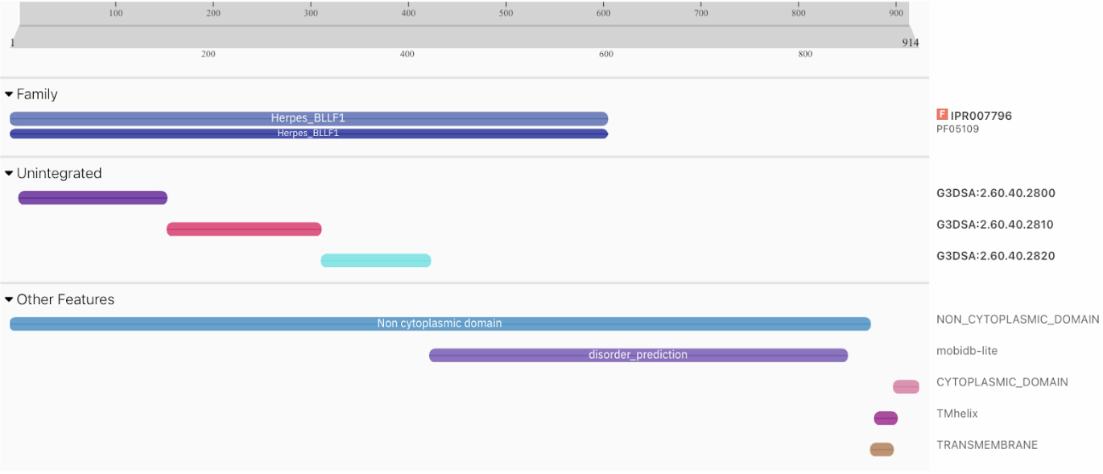
Figure 1. Interpro predicted gp350 expression protein localization and features. The majority of the protein resides in the non-cytoplasmic domain, as indicated by the light blue bar labelled with the same name at amino acids 1-865, signifying extracellular expression, vital for mRNA vaccine efficacy. A transmembrane helix is observed at the C-terminus region 870-892 furthermost to the right in magenta and brown, with no signal present at the n-terminus.

Engineering Signal Sequence and Modifying the ORF:

The BLLF1 protein was determined to lack a signal sequence. To ensure efficient protein synthesis and localization to the cell surface, a signal sequence from the Moderna mRNA vaccine model was incorporated. The first 18 amino acids from the Moderna vaccine model (known as the signal sequence) were inserted at the N-terminus of the BLLF1 mRNA. The original methionine (AUG) start codon of the glycoprotein was removed to maintain consistency with the signal sequence insertion.

Incorporating the 5' and 3’ UTRs and Poly(A) tail:

The 5' untranslated region (UTR) from the Moderna mRNA vaccine model was added in front of the modified ORF, ensuring proper translation initiation. The 3' UTR was appended at the end of the mRNA sequence to maintain the essential regulatory elements required for post-transcriptional control. The poly(A) tail, a chain of adenine nucleotides, was inserted after the 3’ UTR to improve stability and prevent RNA degradation.

Glycoprotein L
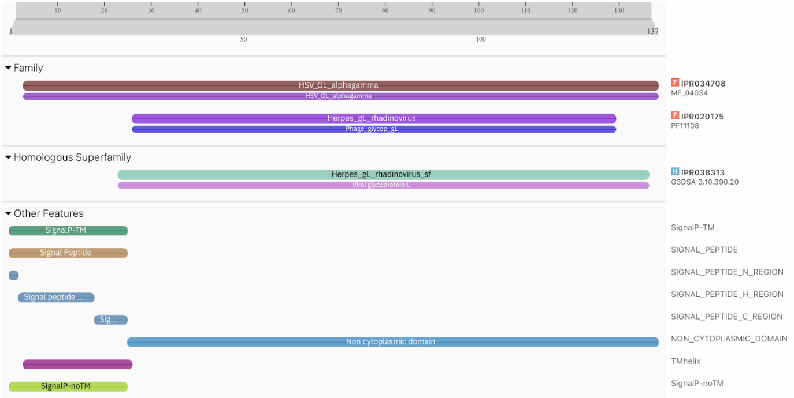
Figure 2. Initial Interpro predicted gL expression. The majority of the protein is predicted to be extracellular as indicated by the non-cytoplasmic domain at amino acids 26-137. The presence of a signal sequence is indicated at the N-terminus of the gL protein amino acid region 1-25 labelled ‘Signal Peptide’ using SignalP-TM or SignalP-nTM. Additionally, a transmembrane helix prediction is observed in magenta at region 4-26, a false positive possibly attributed to the presence of a long stretch of hydrophobic amino acids.

Though Interpro appears to predict a transmembrane helix, upon further research Matsuura et al. (2010) indicates that gL has only a signal sequence and there is no transmembrane domain structure.

Signal Sequence Analysis:

The BKRF2 glycoprotein L was found to possess a signal sequence at the C-terminus with a hydrophobic stretch and no transmembrane helix. The software assessed the glycoprotein L for its propensity to form a transmembrane helix based on the presence of nonpolar/hydrophobic amino acids; however, such a helix formation was proved improbable. The system may not have been able to distinguish between a signal peptide and a transmembrane helix. Further analysis using a newer model of SignalP may be able to verify this (Peterson, 2011).

Identification of the Transmembrane Domain:

To incorporate a transmembrane domain, the transmembrane domain of the SARS-CoV-2 Spike protein was identified as amino acids 1214 to 1236. This stretch of 23 amino acids (from 1214 to 1236) was added into the open reading frame (ORF) immediately before the stop codon. This addition involved inserting 69 bases corresponding to the amino acid sequence.

Incorporating the 5' and 3’ UTRs and Poly(A) tail:

To aid translation initiation, the 5' untranslated region (UTR) from the Moderna mRNA vaccine model was placed in front of the ORF. The 3' untranslated region (UTR) from the Moderna rRNA vaccine model was similarly added to the end of the ORF for better post-transcriptional control. Lastly, a poly(A) tail was added to the end of the candidate vaccine sequence.

Glycoprotein 42
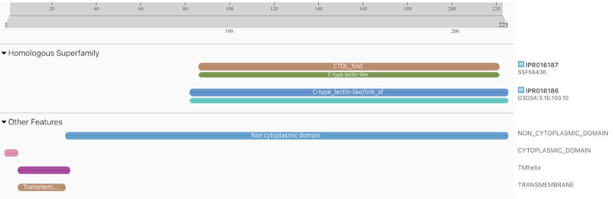
Figure 3. Interpro analysis predicts the expression of gp42 protein. The majority of the protein is predicted to be extracellular as indicated by the non-cytoplasmic domain at amino acids 28-223. A transmembrane helix prediction is indicated in magenta and brown at region 7-29.

Further scrutiny and validation were warranted to confirm the accuracy of this prediction, particularly in the context of its potential role within the vaccine model. Kirschner et al. (2009) in Cell confirm that highly hydrophobic region 9-29 accounts for the transmembrane domain, as well as indicating gp42 is a type-II membrane protein. Therefore, it does not have a traditional signal sequence, as residues 9-29 serve to direct the insertion of the protein into the endoplasmic reticulum membrane.

The method here consisted of repeating the same procedures applied to the other two candidates, where the 5’ and 3’ UTRs from the vaccine model were incorporated into their respective positions. Following that, the poly(A) tail was inserted at the end of the sequence.

Results

Candidate Selection Considerations

Several criteria were used in selecting candidate EBV proteins, informed by the mechanisms that mRNA vaccines rely on to trigger an immune response as well as the primary goals for such a vaccine. These included protein abundance, functional importance, stage of EBV infection, presence of viral envelope, and role in immune evasion. Each criterion deals with how a protein interacts with human host cells, including how often they are expressed extracellularly which affects the likelihood of an immune response, and if the virus can continue to proliferate without it. All of these factors must be considered in the creation of a vaccine prototype with high efficacy. A detailed explanation for each criterion follows below.

Abundance

The abundance of a candidate protein on the plasma membrane of EBV-infected cells can significantly impact its suitability as a vaccine target. Proteins that are heavily expressed during EBV infection are more likely to be exposed to the immune system and may elicit stronger immune responses (Salvatori, 2020). They are also more reliable targets that ensure if successful, the vaccine can defend against most and not just some invading pathogens. Gp350 was an attractive candidate for this reason; it is the most abundantly expressed glycoprotein during the lytic phase of the virus (Slabik, 2020). Examination of transcriptomic and proteomic data can provide insights into protein abundance.

Functional Importance

Consideration of the protein's role in EBV biology is crucial. Proteins that play essential roles in viral entry, immune evasion, or replication may be attractive candidates. This also prevents evolutionary vaccine resistance because the virus cannot adapt to function without said protein. For example, gp350 is involved in viral attachment to host cells, making it a key player in viral proliferation (Slabik, 2020). gL has a prominent role in viral entry and was therefore selected along with gp42 given its involvement in B-cell fusion and immune evasion mechanisms that make it a potential target to disrupt these strategies (Ressing, 2003).

Stages of EBV Infection

EBV undergoes both lytic and latent phases during infection. Proteins that are expressed during these phases may have different immunogenic properties. For example, proteins expressed during the lytic phase may be more readily recognized by the immune system, with a significantly higher frequency of CD8+ T-cells (Callan et al., 1998). It is less common to find reliably expressed proteins in the latent phase as the virus is not active, but gp350 holds promise due to its abundance in the lytic phase and its random expression in detectable amounts in the latent phase (Slabik et al., 2020).

Extracellular Expression

Proteins that are expressed extracellularly and exposed to the host immune system are what the mRNA vaccine mechanism relies on. This includes proteins like gp350, which interacts with host cells during EBV attachment.

Role in Immune Evasion

Proteins involved in immune evasion mechanisms, such as gp42, may be important for the virus's survival and can be attractive vaccine candidates to disrupt these mechanisms.

BLLF1:

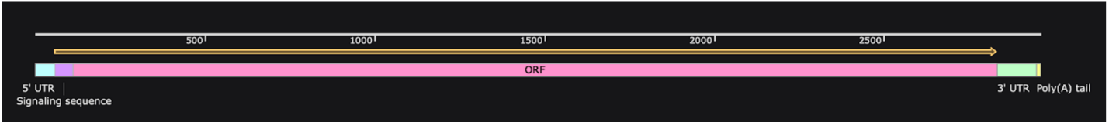
Figure 4. BLLF1. Graphic of the components of the vaccine from left to right with the 5’ UTR in light aqua, the signal sequence in purple, the ORF in pink, the 3’UTR in green and the poly(A) tail in yellow. Total 2957 bases.

BKRF2:

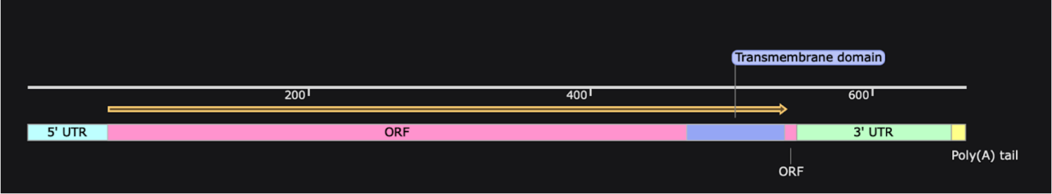
Figure 5. BKRF2. Graphic of the components of the vaccine from left to right with the 5’ UTR in light aqua, the ORF in pink, the transmembrane domain in deeper blue, the 3’UTR in green and the poly(A) tail in yellow. Total 665 bases.

BZLF2:

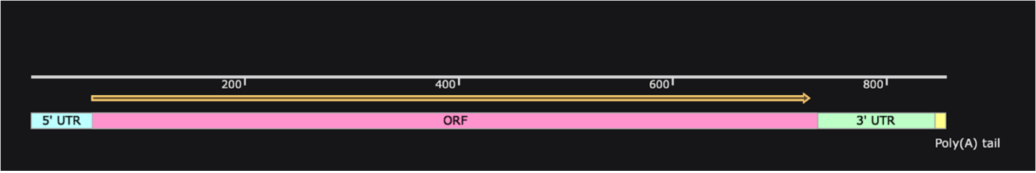
Figure 6. BZLF2. Graphic of the components of the vaccine from left to right with the 5’ UTR in light aqua, the ORF in pink, the 3’UTR in green and the poly(A) tail in yellow. Total 854 bases.

Discussion

To advance our understanding and evaluate the efficacy of the proposed EBNA mRNA vaccine, it is essential to consider prospective testing methods. These methods are crucial for assessing whether the proposed mechanisms will effectively produce the desired immune response. Several testing approaches can be employed as next steps to examine various aspects of the vaccine development process

RNA Generation

The process of developing an RNA vaccine typically begins with the generation of the RNA encoding the antigen of interest. In vitro transcription is a common method used to synthesize the mRNA for the vaccine. This involves using a DNA template that encodes the target antigen. The DNA template contains a promoter region recognized by RNA polymerase, which initiates the transcription process. Promoters like the T7 promoter are commonly used for mass-producing mRNA, after which the RNA polymerase enzyme copies the DNA template, synthesizing the corresponding mRNA (Beckert & Masquida, 2010).

mRNA Capping

Capping of in vitro transcribed (IVT) mRNA is essential for translation efficiency and intracellular stability (Ramanathan et al., 2016). It involves the addition of a cap structure to the mRNA's 5' end, promoting efficient protein synthesis.

Uracil to Pseudouridine Replacement

It has been demonstrated that replacing uracil residues with pseudouridine (Ψ) can enhance the stability of in vitro transcribed RNA, reduce immunogenicity, and improve translation efficiency. Nucleotide modifications play a pivotal role in mRNA-LNP vaccine design. Unmodified mRNA molecules can trigger innate immune responses upon administration. To mitigate this, chemically modified nucleoside Ψ can be incorporated into the mRNA sequence. The choice of modifications should be guided by their impact on both the immune response and protein expression (Morais et al., 2021).

A drawback of implementing this system is the potential expenses associated with it. The core expenses involve purchasing the reagents and materials required for RNA synthesis. This includes nucleotide monomers, enzymes (such as RNA polymerase), buffers, and purification reagents. The cost of these materials depends on the scale of production and the specific RNA sequence being synthesized.

Another prospective method involves leveraging bacterial systems to produce mRNA in vivo. This approach entails engineering bacteria to synthesize mRNA molecules, which can be an efficient and cost-effective way to generate the necessary nucleic acid material. Bacteria can serve as convenient hosts for producing large quantities of mRNA, and common choices include Escherichia coli (E. coli) and other well-established bacteria for molecular biology and biotechnology applications (Liang et al., 2000). A plasmid vector contains a copy of the gene of interest and is delivered to the bacteria, which are grown in a culture medium and are initiated to transcribe mRNA through an inducer molecule that activates the promoter region. This method, if successful, with its high yield, short production time, and reduced reagent costs, could address some of the cost concerns associated with mRNA vaccine production.

Protein Expression/Localization

Immunofluorescence can be utilized to visualize the expression and localization of the EBNA protein within cells. Immunofluorescence involves using antibodies tagged with fluorescent molecules to bind to specific target proteins within the cell. When excited by a specific wavelength of light, the fluorophores’ fluorescence allows visualization of the protein's location (Joshi & Yu, 2017). Cells are fixed, permeabilized to allow antibody penetration, and then incubated with primary antibodies against the target protein. After washing away unbound antibodies, cells are incubated with fluorescently labelled secondary antibodies that bind to the primary antibodies. Immunofluorescence allows us to track the distribution of the target protein within the cellular context, providing insights into its subcellular localization and potential interactions with cellular components.

Western blotting is another technique that can be utilized, not for cellular localization but rather to confirm protein expression in cell lysates as it detects proteins based on their size and immunoreactivity. Protein lysates are separated by gel electrophoresis based on size and transferred onto a membrane (Yang et al., 2012). The membrane is then probed with antibodies against the protein of interest, followed by detection using chemiluminescent or chromogenic substrates. Post-imaging, the data can help confirm the expected expression of the intended proteins.

Enzyme-linked immunosorbent Assay (ELISA) uses antibodies linked with enzymes that react with a substrate to produce a detectable signal (usually colorimetric or chemiluminescent) proportional to the amount of target protein, as stated in StatPearls (Alhajj et al., 2023). ELISA is highly quantitative and can measure protein concentration accurately. Researchers can use it to assess the level of vaccine-encoded protein in samples, such as cell culture supernatants. Calibration curves and standardization are key considerations.

Subsequently, in vitro testing using human cell lines should be conducted to assess the stability, translational efficiency, and immunogenicity of the modified mRNA. These initial studies provide valuable insights into the performance of the vaccine candidate at the cellular level, helping to refine its design. In the vaccine development process what follows is usually animal model testing to evaluate the safety and immunogenicity of the mRNA vaccine candidate. This would involve selecting appropriate animal models, such as mice or non-human primates to mimic human responses, preferably species that naturally are EBV hosts or are modified to interact with the virus as human cells do (Cai et al., 2021).

It is important to monitor their immune responses, including antibody production, T-cell activation, and cytokine profiles. These can verify the vaccine candidate’s ability to induce strong immune responses against the virus and expose any adverse effects or inflammatory responses in the animal subjects.

If animal testing shows promising results, the candidate can then proceed onto ordered clinical trials on humans–from Phase I, administered to a handful of healthy volunteers, to Phase II with a larger group of participants including individuals at risk for EBV, and lastly a large scale Phase III diverse population trial (WHO, 2020). As of now, a vaccine candidate for EBV has not made it past Phase III or regulatory approval, however with new technology and renewed interest in mRNA technology a different approach harnessing mRNA vaccines may see success.

With decades of history and hundreds of researchers contributing to its development, mRNA vaccines are finally gaining recognition for their potential to solve various global health challenges where research with other methods has stagnated. The versatility and speed of development associated with mRNA vaccines hold promise for revolutionizing the field of immunization and responding rapidly to emerging health threats, such as Epstein-Barr virus, fast-mutating pathogens like influenza, or even certain cancers.

References

Alhajj M, Zubair M, Farhana A. Enzyme Linked Immunosorbent Assay. [Updated 2023 Apr 23]. In: StatPearls [Internet]. Treasure Island (FL): StatPearls Publishing; 2023 Jan-. Available from: https://www.ncbi.nlm.nih.gov/books/NBK555922

Beckert, B., & Masquida, B. (2010). Synthesis of RNA by in vitro transcription. RNA, 29-41. https://doi.org/10.1007/978-1-59745-248-9_3

Bjornevik, K., Cortese, M., Healy, B. C., Kuhle, J., Mina, M. J., Leng, Y., Elledge, S. J., Niebuhr, D. W., Scher, A. I., Munger, K. L., & Ascherio, A. (2022). Longitudinal analysis reveals high prevalence of epstein-barr virus associated with multiple sclerosis. Science, 375(6578), 296-301. https://doi.org/10.1126/science.abj8222

BKRF2 [Human gammaherpesvirus 4] [Internet]. Bethesda (MD): National Library of Medicine (US), National Center for Biotechnology Information; 2004 – [cited 2023 Oct 19]. Available from: https://www.ncbi.nlm.nih.gov/protein/UQK62613.1

BLLF1 [Human gammaherpesvirus 4] [Internet]. Bethesda (MD): National Library of Medicine (US), National Center for Biotechnology Information; 2004 – [cited 2023 Oct 19]. Available from: https://www.ncbi.nlm.nih.gov/protein/QCG99665.1

BLLF1 [Human gammaherpesvirus 4] [Internet]. Bethesda (MD): National Library of Medicine (US), National Center for Biotechnology Information; 2004 – [cited 2023 Oct 19]. Available from: https://www.ncbi.nlm.nih.gov/protein/QCG99665.1

Cai, J., Zhang, B., Li, Y., Zhu, W., Akihisa, T., Li, W., Kikuchi, T., Liu, W., Feng, F., & Zhang, J. (2021). Prophylactic and therapeutic EBV vaccines: Major scientific obstacles, historical progress, and future direction. Vaccines, 9(11), 1290. https://doi.org/10.3390/vaccines9111290

Callan, M., Tan, L., Annels, N., Ogg, G., Wilson, J., O'Callaghan, C., Steven, N., McMichael, A., & Rickinson, A. (1998). Direct visualization of antigen-specific cd8+t cells during the primary immune response to epstein-barr virus in vivo. The Journal of Experimental Medicine, 187(9), 1395-1402. https://doi.org/10.1084/jem.187.9.1395

Cohen, J. I. (2015). Epstein–barr virus vaccines. Clinical & Translational Immunology, 4(1). https://doi.org/10.1038/cti.2014.27

Cohen, J. I., M.D. (2000). Epstein–Barr Virus Infection. New England Journal of Medicine, 342, 481-492. https:///doi.org/10.1056/nejm200008173430707

Dotmatics. (2023). SnapGene® software [Computer software]. https://snapgene.com
Used to modify nucleotide sequences and create figures.

Farrell, P. J. (2019). Epstein–Barr virus and cancer. Annual Review of Pathology: Mechanisms of Disease, 14(1), 29-53. https://doi.org/10.1146/annurev-pathmechdis-012418-013023

Forni, D., Cagliani, R., Clerici, M., & Sironi, M. (2022). Disease-causing human viruses: Novelty and legacy. Trends in Microbiology, 30(12), 1232-1242. https://doi.org/10.1016/j.tim.2022.07.002

Joshi, S., & Yu, D. (2017). Immunofluorescence. Basic Science Methods for Clinical Researchers, 135-150. https://doi.org/10.1016/b978-0-12-803077-6.00008-4

Kirschner, A. N., Sorem, J., Longnecker, R., & Jardetzky, T. S. (2009). Structure of epstein-barr virus glycoprotein 42 suggests a mechanism for triggering receptor-activated virus entry. Structure, 17(2), 223-233. https://doi.org/10.1016/j.str.2008.12.010

Liang, S.-T., Xu, Y.-C., Dennis, P., & Bremer, H. (2000). MRNA composition and control of bacterial gene expression. Journal of Bacteriology, 182(11), 3037-3044. https://doi.org/10.1128/jb.182.11.3037-3044.2000

Mathieu, E., Ritchie, H., Rodés-Guirao, L., Appel, C., Giattino, C., Hasell, J., Macdonald, B., Dattani, S., Beltekian, D., Ortiz-Ospina, E., & Roser, M. (2020) Total COVID-19 vaccine doses administered. Our World in Data. https://ourworldindata.org/grapher/cumulative-covid-vaccinations

Matsuura, H., Kirschner, A. N., Longnecker, R., & Jardetzky, T. S. (2010). Crystal structure of the epstein-barr virus (EBV) glycoprotein h/glycoprotein L (gH/gL) complex. Proceedings of the National Academy of Sciences, 107(52), 22641-22646. https://doi.org/10.1073/pnas.1011806108

Morais, P., Adachi, H., & Yu, Y.-T. (2021). The critical contribution of pseudouridine to mRNA covid-19 vaccines. Frontiers in Cell and Developmental Biology, 9. https://doi.org/10.3389/fcell.2021.789427

Office of Infectious Disease and HIV/AIDS Policy (OIDP). (2022). Vaccines by disease. HHS.gov. https://www.hhs.gov/immunization/diseases/index.html

Pardi, N., Hogan, M. J., Porter, F. W., & Weissman, D. (2018). MRNA vaccines — a new era in vaccinology. Nature Reviews Drug Discovery, 17(4), 261-279. https://doi.org/10.1038/nrd.2017.243

Paysan-Lafosse T, Blum M, Chuguransky S, Grego T, Pinto BL, Salazar GA, Bileschi ML, Bork P, Bridge A, Colwell L, Gough J, Haft DH, Letunić I, Marchler-Bauer A, Mi H, Natale DA, Orengo CA, Pandurangan AP, Rivoire C, Sigrist CJA, Sillitoe I, Thanki N, Thomas PD, Tosatto SCE, Wu CH, Bateman A. InterPro in 2022. Nucleic Acids Research, Nov 2022. https://doi.org/10.1093/nar/gkac993

Petersen, T. N., Brunak, S., von Heijne, G., & Nielsen, H. (2011). SignalP 4.0: Discriminating signal peptides from transmembrane regions. Nature Methods, 8(10), 785-786. https://doi.org/10.1038/nmeth.1701

Ramanathan, A., Robb, G. B., & Chan, S.-H. (2016). MRNA capping: Biological functions and applications. Nucleic Acids Research, 44(16), 7511-7526. https://doi.org/10.1093/nar/gkw551

Ressing, M. E., van Leeuwen, D., Verreck, F. A. W., Keating, S., Gomez, R., Franken, K. L. M. C., Ottenhoff, T. H. M., Spriggs, M., Schumacher, T. N., Hutt-Fletcher, L. M., Rowe, M., & Wiertz, E. J. H. J. (2005). Epstein-Barr virus gp42 is posttranslationally modified to produce soluble gp42 that mediates HLA class II immune evasion. Journal of Virology, 79(2), 841-852. https://doi.org/10.1128/jvi.79.2.841-852.2005

Salvatori, G., Luberto, L., Maffei, M., Aurisicchio, L., Roscilli, G., Palombo, F., & Marra, E. (2020). SARS-CoV-2 SPIKE protein: An optimal immunological target for vaccines. Journal of Translational Medicine, 18(1). https://doi.org/10.1186/s12967-020-02392-y

Slabik, C., Kalbarczyk, M., Danisch, S., Zeidler, R., Klawonn, F., Volk, V., Krönke, N., Feuerhake, F., Ferreira de Figueiredo, C., Blasczyk, R., Olbrich, H., Theobald, S. J., Schneider, A., Ganser, A., von Kaisenberg, C., Lienenklaus, S., Bleich, A., Hammerschmidt, W., & Stripecke, R. (2020). CAR-T cells targeting epstein-barr virus gp350 validated in a humanized mouse model of EBV infection and lymphoproliferative disease. Molecular Therapy - Oncolytics, 18, 504-524. https://doi.org/10.1016/j.omto.2020.08.005

Surface glycoprotein [Severe acute respiratory syndrome coronavirus 2] [Internet]. Bethesda (MD): National Library of Medicine (US), National Center for Biotechnology Information; 2004 – [cited 2023 Oct 19]. Available from: https://www.ncbi.nlm.nih.gov/protein/YP_009724390.1

Synthetic construct HCV1146 Moderna (mRNA-1273) SARS-CoV-2 vaccine sequence [Internet]. Bethesda (MD): National Library of Medicine (US), National Center for Biotechnology Information; 2004 – [cited 2023 Oct 19]. Available from: https://www.ncbi.nlm.nih.gov/nuccore/OK120841.1

World Health Organization: WHO. (2020). Clinical trials. www.who.int. https://www.who.int/health-topics/clinical-trials#tab=tab_1

Yang, P.-C., & Mahmood, T. (2012). Western blot: Technique, theory, and trouble shooting. North American Journal of Medical Sciences, 4(9), 429. https://doi.org/10.4103/1947-2714.100998

