Achieving Sustainability: PepsiCo’s ESG and Customer Perception

Xinning Liu
September 2023

Introduction
Opportunity cost refers to what you have to give up to buy what you want in terms of other goods or services (“Opportunity Cost,” 2023). When we discuss opportunity cost in business,
OC (opportunity cost) = FO (return on best forgone option) − CO (return on chosen option)
(Fernando, 2023). Due to the high utilization rate of environmental resources and the damage suffered by the environment, many businesses are thinking about reducing their environmental impact. At the same time, the switch to sustainable practices will consume a lot of money. Therefore, some enterprises give up the goal of sustainable development to obtain higher profits. In practice, sustainable development and business are not contradictory. For instance, in Mexico, PepsiCo partnered with local farmers to switch from corn to sustainable sunflowers. PepsiCo thinks that investing in environmental, social and governance (ESG) investing is essential and will help their business thrive in the long term (“PepsiCo ESG Summary,” 2023).
PepsiCo created a goal of zero carbon emissions by 2040, and made a detailed plan for agriculture, packaging, direct operation, third-party manufacturing, and more (“Climate Change,” 2023a). Several changes have been made to the production steps and raw materials. In this study, the application of opportunity cost in PepsiCo's business decision will be explained in detail, and the rationality of the choice will be compared through calculation. Furthermore, this study combines consumer preference literature, primary data obtained by questionnaire, and professional suggestions for sustainable development collected in interviews to analyze and explain in detail the impact of ESG business decision on customers, partners, and even society. Benefits and disadvantages to ESG are explained. Much of the existing business literature overlooks sustainable development in major companies. This article will focus on PepsiCo and analyze its decisions using an economic framework.
This paper is divided into seven parts: literature review, purpose, research methods, case analysis, results, conclusion, and references.
Purpose
Through this research, I want to (1) explain the relationship between opportunity cost and business choices made by companies regarding sustainable development, and (2) understand consumers' opinions on their measures through questionnaire surveys. The paper will explain when the ESG decision is a benefit or loss for an enterprise, as well as the impact ESG commitments on consumers and society.
Research methods
The study uses an opportunity cost estimation to determine whether ESG investments can bring economic benefits to PepsiCo or contribute to sustainable projects. Second, a questionnaire survey was conducted on consumer responses in the early stages of the project. The survey data will also be used to support the interpretation of consumers' perception of PepsiCo's plans to achieve its sustainability goals along with interviews with PepsiCo employees who are committed to sustainable development.
Case Analysis
Consumer Perception of ESG
Employees and customers are willing to pay significantly more to do business with a company with an ESG policy (Finger & Rosenboim, 2022). There are direct positive effects of social and governance dimensions of perceived ESG on brand credibility, brand image, and perceived quality (Koh et al., 2022). Food and beverage companies’ ESG management activities directly affect consumers’ brand trust and word-of-mouth intention (Bae et al., 2023). However, company performance does not seem to be affected by ESG commitments (La Torre, 2020). ESG reporting does not fully explain customer perception of social innovativeness (Aksoy, 2022).
Opportunity Cost at PepsiCo
PepsiCo's definition of sustainable development goals does not align with the traditional sense of reducing carbon emissions or making positive contributions to the environment. Through this project, they also hope to combine different regional characteristics to expand sales scale and social influence to improve affinity and company image (PepsiCo, personal communication, July 2023). For example, in South Africa in April 2021, PepsiCo built a football field with 100% recyclable turf and shock-absorbing layers (“Lay’s Replay,” 2021). The shock-absorbing layer is made from recycled potato chip packaging. The move required the consumption of more than three million potato chip packages. These potato chip packages built a football field and reduced greenhouse gas emissions by 128 tons compared with traditional construction methods, which is equivalent to taking 27 cars off the road for a whole year (“Lay’s Replay,” 2021).
In terms of opportunity cost, what PepsiCo loses is more than three million potato chip packages and the money to build the stadium, and what it gets is the reduction of 128 tons of greenhouse gases (“Lay’s Replay,” 2021), which slows down the greenhouse effect. At the same time, they let refugees play football. In other words, what they get is social influence in South Africa and a corporate image that cares about the underprivileged. This is a very worthwhile trade. They have gained far more than they have lost. Social influence is sometimes considered to be unreliable, but in this case, it's the key to making a profit. The numbers speak volumes for what PepsiCo has achieved. After the public, especially the South African people know about this, they will be positively influenced, and they will be willing to buy PepsiCo's products because they feel that their purchase of products is also helping PepsiCo reduce more carbon emissions. As sales increase, profits naturally increase. The profits obtained can be used for further research and development on recycling product packaging, use of renewable energy, production chains, and more.
A second example concerns technologies that recycle water. First, it is common knowledge that drinking water resources are very scarce. As a result, PepsiCo has chosen to use recycled water technology in India to reduce water consumption at its factories. The team has reduced water usage by 70 percent at the Channo facility since 2016 (Manpreet, personal communication, July 2023). The team is creating rainwater harvesting ponds and collecting water from villages, which is treated and being reused locally. Second, The Fanta factory is in Colombia, one of the rainiest countries in the world (“PepsiCo ESG Summary,” 2023b). They thought of using rainfall to recycle water and purify it for reuse in production. They just needed to figure out how to keep the rainwater out of contact with the groundwater and to be able to collect a lot of rainwater. Later, the factory achieved the result of zero use of fresh water, and the factory has a water circulation system. Considering the water usage rate, PepsiCo will replenish 100% of the water used by the factory back to the river in 2021 and has replenished 6.1 billion liters of water. PepsiCo intends to invest $2.1 million to support wetland restoration in Winter Haven, Florida. PepsiCo and the PepsiCo Foundation have helped deliver to more than 80 million people globally over the past 15 years (“PepsiCo ESG Summary,” 2023b).
The proportion of PepsiCo’s investment in recycling and reuse of water resources is huge, even without return. In terms of money, FO includes the cost of hiring a team, the technical cost of recycling rainwater (very high), the treatment cost of separating rainwater from groundwater, and the cost of resupplying water to the factory, and even PepsiCo invested 2.1 million dollars to help wetlands achieve water recycling and reuse. Economically, the choice of FO close to CO, meaning the opportunity cost (FO - CO) is not equal to zero. This business choice helps PepsiCo grow. From a business perspective, this choice has helped PepsiCo make progress in its sustainability program. At the same time, it has gained good social influence and corporate image. This is also technological progress, and it is a very big progress in reducing greenhouse gas emissions. This choice is correct, it reflects PepsiCo's sense of responsibility and his original intention to bring smiles to customers and the planet.

Survey Results
Figure 1
Basic Information on Questionnaire
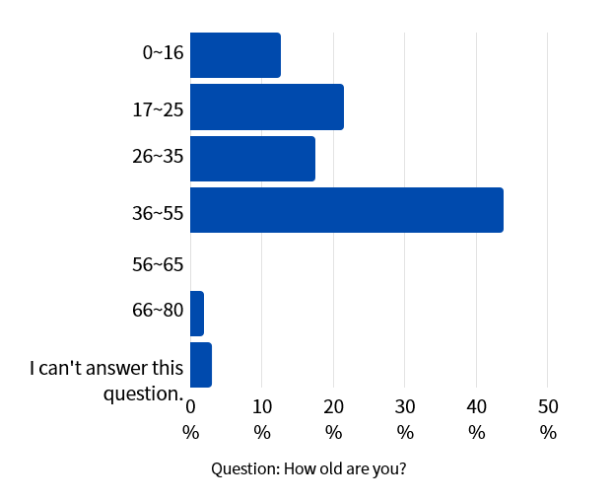
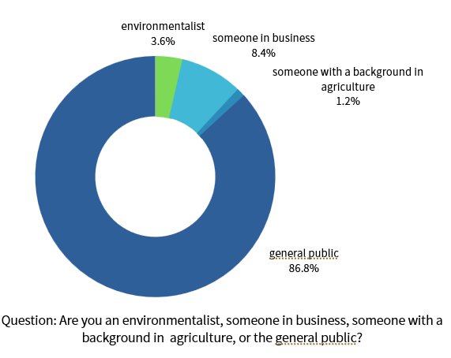
The total number of questionnaires released was 102, and the people are distributed in different age groups. Most of the age groups surveyed by the questionnaire are in line with PepsiCo's wide-ranging target customer group. Most of the respondents are the members of the general public, but there are also professionals: 3.6% were environmentalists, 8.4% were someone in business, and 1.2% were someone with a background in agriculture (Fig. 1).
Figure 2
Questionnaire Respondents
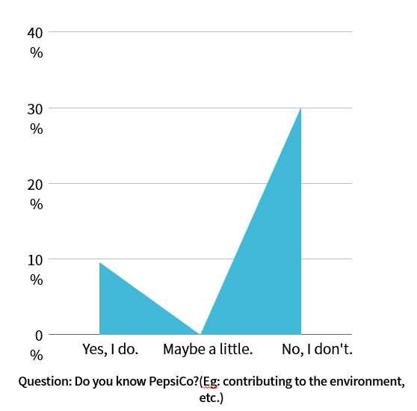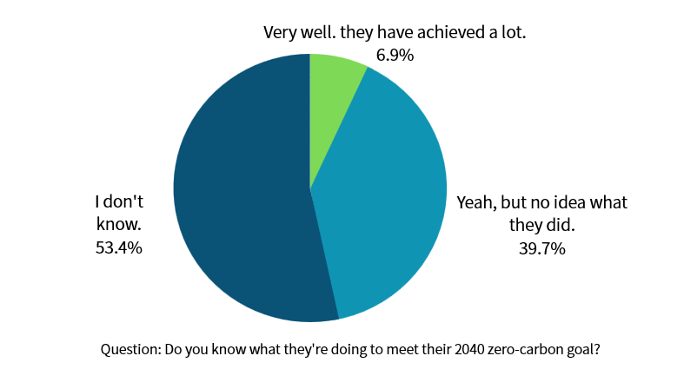
The survey found that 53.4% ​​of the total number of respondents did not know about this project (Fig. 2). It shows that PepsiCo's contribution to sustainable projects is not understood by most people, but according to PepsiCo’s Sustainability Manager, they hope that the contribution they make will be perceived by consumers. They want consumers to see the value behind the product. They released surveys targeting consumers in China, Thailand and elsewhere (PepsiCo, personal communication, July 2023). Unfortunately, the survey data shows that consumers' perception is not high. The customer base does not understand PepsiCo's contribution to the environment. Therefore, PepsiCo must strategize to publicize this achievement or increase changes at the consumer level to attract consumers' attention.

Figure 3
Questionnaire Consumer Perception
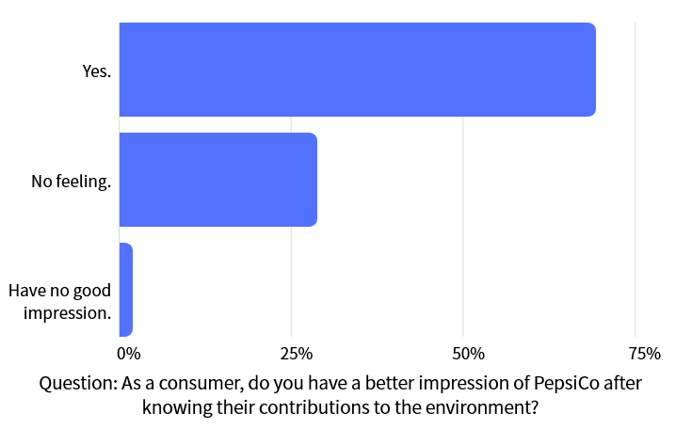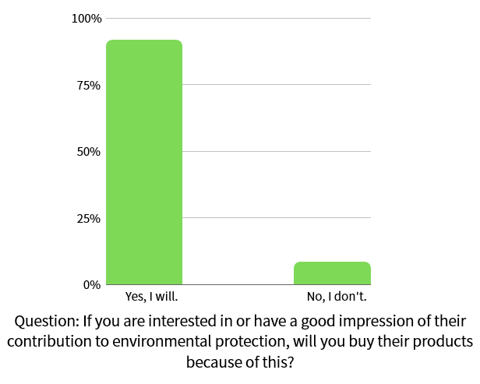
The data gathered for these two questions reveals low consumer awareness of PepsiCo's sustainability program. The survey data shows that once consumers perceive PepsiCo's measures to reduce environmental impact, they will have a good impression and even be willing to buy PepsiCo's products (Fig. 3). If PepsiCo can do this, it will increase their income and attract many consumers because consumers are concerned about corporate responsibility and the environment.
Limitations
This study explores consumer awareness of PepsiCo with several significant limitations. There was a relatively low number of survey respondents considering the global nature of the PepsiCo brand. This results in the survey data are not universally applicable on a global scale. This study also does not address the general role of ESG as a part of an investment package or the specific details of PepsiCo’s ESG plan. This study does not discuss different customer responses based on location or demographics. This research is intended to inspire many questions, but does not answer all of them definitively.
Conclusion
The business choices made by PepsiCo for sustainable development projects are all valuable, and from an economic point of view, FO = CO, which shows that the decision is economically preferable. However, their contribution was not perfectly perceived by customers. Affinity marketing initiatives, especially social marketing initiatives, have the potential to improve consumers' attitudes about the PepsiCo brand.
References
Aksoy, L., Buoye, A. J., Fors, M., Keiningham, T. L., & Rosengren, S. (2022). Environmental, Social and Governance (ESG) Metrics Do Not Serve Services Customers: A Missing Link Between Sustainability Metrics and Customer Perceptions of Social Innovation. Journal of Service Management, 33(4/5), 565–577. https://doi.org/10.1108/josm-11-2021-0428
Bae, G. K., Lee, S. M., & Luan, B. K. (2023). The Impact of ESG on Brand Trust and Word of Mouth in Food and Beverage Companies: Focusing On Jeju Island Tourists. Sustainability, 15(3), 2348. https://doi.org/10.3390/su15032348
Bloom, P. N., Hoeffler, S., Keller, K. L., & Basurto Meza, C. E. (2006). How Social-Cause Marketing Affects Consumer Perceptions. MIT Sloan Management Review, 47(2).
Climate change. Pepsico. (2023a). https://www.pepsico.com/our-impact/esg-topics-a-z/climate-change#progress
Fernando, J. (2023, March 17). Opportunity Cost Formula, Calculation, and What It Can Tell You. Investopedia. https://www.investopedia.com/terms/o/opportunitycost.asp
Finger, M., & Rosenboim, M. (2022). Going ESG: The Economic Value of Adopting an ESG Policy. Sustainability, 14(21), 13917. https://doi.org/10.3390/su142113917
Koh, H. K., Burnasheva, R., & Suh, Y. G. (2022). Perceived ESG (Environmental, Social, Governance) and Consumers’ Responses: The Mediating Role of Brand Credibility, Brand Image, and Perceived Quality. Sustainability, 14(8), 4515. https://doi.org/10.3390/su14084515
La Torre, M., Mango, F., Cafaro, A., & Leo, S. (2020). Does the ESG Index Affect Stock Return? Evidence From the Eurostoxx50. Sustainability, 12(16), 6387. https://doi.org/10.3390/su12166387
Lay’s Replay Gives Chip Packaging New Purpose. Pepsico. (2021, June 24). https://www.pepsico.com/our-stories/story/lay’s-replay-gives-chip-packaging-new-purpose#:~:text=In%20partnership%20with%20the%20UEFA,fields%20(aka%20football%20pitches).
Opportunity Cost. Econlib. (2023, August 30). https://www.econlib.org/library/Topics/College/opportunitycost.html
PepsiCo ESG Summary. Pepsico. (2023b). https://www.pepsico.com/our-impact/sustainability/esg-summary
Questionnaire. (2023). https://www.wjx.cn/vm/Q4Ohozd.aspx#; https://www.wjx.cn/vm/exQKtFT.aspx#
Target market of Pepsi. Bartleby. (n.d.). https://www.bartleby.com/essay/Target-Market-Of-Pepsi-FCRULWGFFR

