Portfolio Optimization through Machine Learning
Suhas Adavelly
Freedom High School

Abstract

A major challenge in the field of quantitative finance is maximizing risk-adjusted returns. In this article, we present a method for developing a portfolio of stocks that attempts to balance risk and reward to achieve this goal. To do so, we divided the returns of each security in the portfolio by the risk of that security, determined by the negative volatility of the previous year’s prices, and used these scores to determine what percent of the portfolio should be allocated to each security. Our method outperformed the majority of the stocks included in the portfolio and outperformed even weighting of each stock. From the results of this experiment we concluded that it is possible to devise a portfolio that performs better than even allocation; however, the final optimized portfolio was not without risks and did not produce returns as large as the best possible portfolio. In summary, our method provides a reasonable starting point for investors interested in maximizing risk-adjusted returns, with the possibility for improvement in future work.

Introduction

It is a common position that the stock market is unpredictable and that many well-known investors say that there is no way to accurately predict the market and stock price (Malkiel). But due to recent advancements in machine learning, this statement may not be accurate anymore. In this article, we present a way for investors to optimize their portfolio, allowing them to lower the risk that they would face so that the regular retail investor could effectively earn profit and reach financial stability through investments in stocks and other securities. To do so we used past performance of stocks to model the future risk and returns of each stock to determine how a portfolio should be allocated between different stocks. Our solution aimed to optimize and find the best potential combination of given stocks to allow for the greatest return to risk ratio.
Artificial intelligence and machine learning currently have many uses in risk management within financial services (Atwal, Bryson). These uses include managing credit risk, market risk, operational risk, and compliance risk. In this article, we focus on market risk. Machine learning is heavily used in quantitative finance, which focuses on the mathematical modeling of financial markets. Quantitative financial firms focus on predicting the market effectively using machine learning. Machine Learning is also heavily used in algorithmic trading, high frequency trading, and portfolio management. Algorithmic trading is the practice of trading securities based on predetermined factors. High frequency trading is a form of algorithmic trading which uses vast quantities of stocks and shares are bought and sold at high speeds. There are also AI powered portfolios such as AIEQ which use artificial intelligence to manage portfolios (https://etfmg.com/funds/aieq/). Unlike all the previously stated examples, which focus on complex solutions for institutional investors, in this article we examine methods for retail traders to benefit from machine learning without being entirely reliant on it, finding a way for machine learning to help improve a trader’s real-life skills to optimize their own portfolio.

Methods

Our specific objective was to optimize a portfolio’s allocation to a given set of securities to create a portfolio that maximizes risk adjusted returns. The typical method for calculating risk adjusted returns factors in all changes in a stock’s price, including both positive and negative changes. Building on prior work (Swisher, Kasten), we rejected this quantification of risk as it also factors in positive movements, which would penalize a stock even though it went up in price. Instead, we calculated the risk by only factoring negative changes in the stock price, as negative variation is the true risk the one will face while investing. Finally, to find the value for risk adjusted returns we divide the annualized daily returns with annualized daily negative variation. We use this value to optimize the allocation weights for the set of securities tested.

We analyzed a portfolio consisting of shares of Costco, Apple, Nvidia, Meta, and Johnson and Johnson. We used these stocks because they gave an accurate view over multiple industries such as retail, health care, technology, and social media. We also included two technology hardware companies, Apple and Nvidia, to see how our algorithm would handle companies in the same sector. The companies we used are all large corporations that have been listed on the public markets for decades. We chose to take information from after the year 2000 as this time period is the most representative of the current financial environment. Prior to this time, many large technology companies were not created and many technology companies did not become successful prior to 2000, so we determined that this time period included the most relevant information. We used the yfinance API to collect historical market data,using the daily market closing price for each stock.

Our approach was to use past data to determine how much of the portfolio we should allocate to each stock. We backtested the approach by simulating the construction of a portfolio over the past 23 years, rebalancing the portfolio annually. We used data from 2000 to the start of the year we were predicting to determine the weights or percentage of the total portfolio we should invest in the stock. For example, if we were rebalancing the portfolio in January 2012, we used data from 2000-2011 inclusive. To determine the weights, we randomly simulated 5000 portfolios and measured the performance of each portfolio against historical data to find which portfolio had the highest risk adjusted return. To test the portfolio, we used data from the “future” to test the ability of the previously mentioned portfolio. For example, if we used data from 200-2011 for rebalancing the portfolio in 2012, we tested this portfolio with the historical data from 2012, repeating this process in a loop for all the years since 2000 to measure how the results changed depending on the year.

Results

 | Our method | Even weights | 100% JNJ | Ideal | 100% COST | 100% APPL | 100%  NVDA | 100%  Ford
Return | 19.8% annualized | 16.3% | 5.6% | 53.3% | 11.1% | 30.8% | 23.01% | 3.2%
Risk | 21.9% | 15.0% | 11.4% | 17.5% | 15.4% | 21.2% | 33% | 25.1%

This table shows the annualized return and risk used when calculated using our method. The returns are self explanatory where we use daily returns. The risk is calculated using daily negative volume. For our method, we developed a portfolio with an annualized return of 19.8% with a risk value of 21.9%. For an even weighted portfolio of these stocks, we found that the annualized return was 16.3% with a risk value of 15%. If one invested 100% of their money into Johnson and Johnson, their portfolio would return 5.6% and have a risk value of 11.4%. The perfect portfolio which was developed by using data from the “future” time period which has a return of 53.3% and a risk value of 17.6%. Costco stock had a return of 11.1% and a risk value of 15.4%. Apple stock has a return of 30.8% with a risk value of 21.2%. Nvidia has a return of 23.01% with a risk value of 33%. Ford stock has a return of 3.2 % and a risk value of 25.1%.

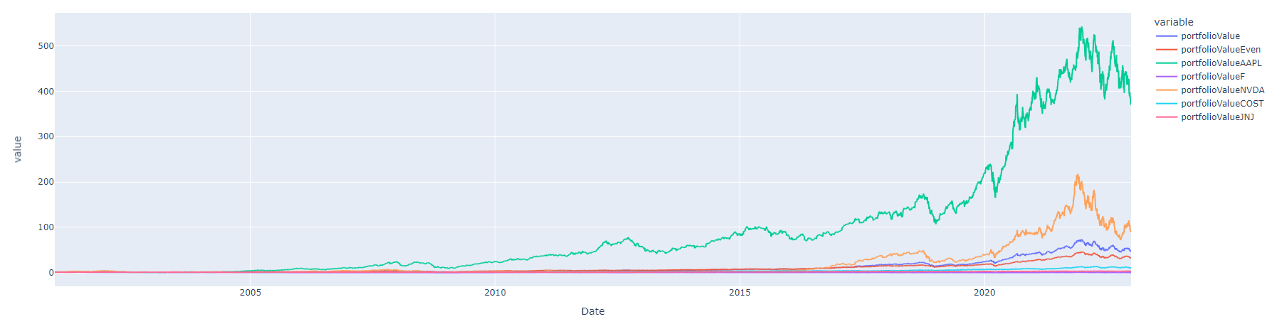

Discussion

From the individual stocks that make up our portfolio, putting all your money in Apple performed the best. The optimized method performed third overall being surpassed by both Apple and Nvidia. Both Apple and Nvidia were much more volatile then the optimized method fluctuating at a much greater scale.

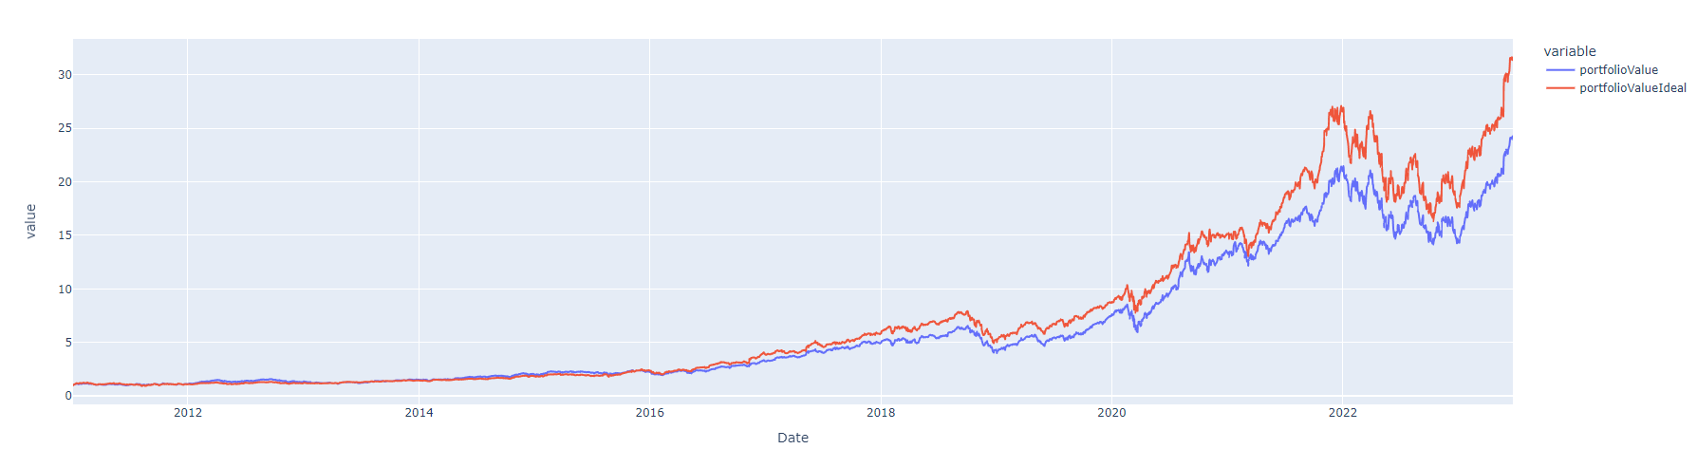
From this graph, our optimizer was used one time at the start of the period and we tracked the performance of the portfolio from 2010-2023. We determined the Ideal portfolio by using information for 2010-2023 while we determined our portfolio by using information from 2000-2010. As you can see, both portfolios performance were alike but the Ideal beat our portfolio slightly.

From these graphs, our optimized portfolio had a good combination of high risk and high return. Our optimizer detects trends in the price in the short term and long term to decide its contents allowing it to provide a high return while also not being as risky as some stocks. This can be seen with Apple and Nvidia. Even though they outperformed our optimized portfolio, they had large price fluctuations leading them to lose a great deal relative to our portfolio. Our portfolio tries to create the best combination of stocks without allocating the entirety to one stock.

Some potential improvements we could make are rebalancing the portfolio more times and changing the time frame. If we just included recent times, this could potentially change the results making it go heavier in tech stocks as those stocks have been booming comparatively to other stocks. If we were to rebalance more times in a year, our portfolio would have a better ability to determine trends in the prices of stocks potentially making performance better.

Conclusion

Our method optimizes a portfolio of stocks by calculating the risk adjusted return by using a stocks daily return and daily negative volume. This is different from other Stock optimizers as they just use total volume in their calculations. Using this, we run thousands of combinations for the portfolio to see which provides the largest ratio for the risk adjusted return. This portfolio is then tested against an even weighted portfolio and the best possible portfolio to determine how our portfolio did relatively. Our portfolio offered low risk without the sacrifice of returns. It performed well in both manners.

In the future, we could enhance our algorithm using principles like mean revision. We could also use sentiment analysis to get a better understanding of short term trends to better optimize our portfolio every year, allowing for even better returns.

Work cited

Malkiel, B.G. (1989). Efficient Market Hypothesis. In: Eatwell, J., Milgate, M., Newman, P. (eds) Finance. The New Palgrave. Palgrave Macmillan, London. https://doi.org/10.1007/978-1-349-20213-3_13

Atwal, G, Bryson, D. Antecedents of intention to adopt artificial intelligence services by consumers in personal financial investing. Strategic Change. 2021; 30: 293–298. https://doi.org/10.1002/jsc.2412

Swisher, Pete; Kasten, Gregory W. Journal of Financial Planning; Denver Vol. 18, Iss. 9, (Sep 2005): 74-76,78,80,82-85.

