Examining the impact of social media marketing on brand awareness and consumer reach for business

ABSTRACT

In today's market conditions, incorporating digital channels to establish and sustain a competitive edge is imperative for businesses. Social media has revolutionized the digital marketing landscape by making it easier for businesses to communicate, engage and gather insights from their target audience, thereby shifting the dynamics and customer expectations. Given the current economic climate and the myriad issues that businesses face, this transition has left them unsure about how to effectively navigate this changing terrain. This research will examine the impact of social media marketing practices of the top two shoe brands in the United States and their influence on brand awareness, customer engagement and the potential to broaden their global customer reach. The study will employ a content analysis approach to assess their promotional approaches, engagement based on the type of posts and content strategies to gather valuable insights on successful social media marketing strategies. This will help businesses in learning how to successfully engage their target audience on social media and optimize their social media presence in the future to increase their competitive edge and business growth.

Introduction

Social media marketing is transforming in response to a range of factors, such as competition, customer preferences, economic conditions, environmental concerns, government regulations, and technological advancements (Lim, 2023). Social media has revolutionized marketing by creating enduring, interactive relationships defined by intimacy, mutual comprehension, mutual care, and uninterrupted communication. Therefore, effective social media marketing requires a focus on the target audience, which is attainable through accurate identification, emotional engagement, leveraging opinion leaders' influence, and maintaining regular communication to sustain enthusiasm (Wang, 2015).
The objective in marketing is to exceed competitors by delivering exceptional value to customers, generating profits for the company, and benefiting all involved stakeholders (Lim, 2023). Individuals are engaging more with digital and social media platforms for various purposes, including as consumers to seek product information, make purchases, consume, and share their experiences. Consequently, marketers have intensified their use of digital marketing channels. The growth of social media persists without any signs of slowing down, demonstrating an uninterrupted trajectory with a global expenditure for digital advertising estimated to be 522.5 billion U.S. dollars in 2021(Digital Ad Spend Worldwide 2026 | Statista, 2023). Projections indicate that this spending is going to surge to 836 billion dollars by 2026 (Digital Ad Spend Worldwide 2026 | Statista, 2023). Thus, further investigation into social media marketing strategies is essential to understand better changes in consumer behavior.
In today's market conditions, incorporating digital channels to establish and sustain a competitive edge is imperative for businesses. The goal is to surpass competitors by offering superior value to customers, generating profits for the company, and benefiting all stakeholders involved (Lim, 2023). Social media platforms are in a perpetual state of flux, fostering a dynamic atmosphere, which has transformed into a vital intelligence source for businesses, thereby allowing them to observe, analyze, and predict customer behaviors (Li et al., 2020). As a result, marketers must strategically harness social media to achieve a competitive advantage and exceptional performance. The strategic capability of utilizing social media allows companies to make more efficient strategic decisions. By effectively leveraging social media, these firms can identify new business opportunities, assess potential threats, and sustain their competitiveness (Cao et al., 2020). Nevertheless, a research gap exists in understanding the influence of social media marketing strategies on consumer behavior.
Consequently, it is imperative to conduct additional research to explore the most effective social media marketing strategies capable of enhancing brand visibility, gaining valuable customer insights, predicting upcoming trends, fostering relationships, and effectively reaching the intended consumers. The evolving landscape of social media marketing, driven by emerging technologies, changing consumer expectations, and shifting dynamics, has left companies with uncertainties on how to effectively navigate this transformative terrain. This becomes particularly important in the present economic climate where businesses strive to differentiate themselves and thrive amidst various challenges.
The study will examine the impact of social media marketing practices of the top two shoe brands in the United States and their influence on brand awareness, customer engagement and the potential to broaden their global reach and influence consumer behavior, leading them to visit the brands' websites. This research will employ a content analysis approach to assess their promotional approaches, engagement based on the type of posts and content strategies to gather valuable insights on successful social media marketing strategies. This will help businesses in learning how to successfully engage their target audience on social media and optimize their social media presence in the future to increase their competitive edge and business growth. The following research question is at the core of this study: How can social media marketing strategies effectively influence consumer reach and behavior?

Traditional Marketing versus Social Media Marketing

All Traditional marketing refers to the conventional approach used by companies to promote their products and services to their prospective customers through broadcast technologies, consisting of newspaper, magazine, radio, and television advertisements (Mehmeti-Bajrami et al., 2022). While traditional marketing, like social media marketing, aims to increase awareness of the goods or services and may reach a wider audience through television and print advertisements, it is less targeted and does not provide the opportunity for businesses to establish connections with their customers to inspire brand loyalty. Chief marketing officers (CMOs) in the US reported that their digital spending climbed by 8.2 percent over the previous 12 months, while spending on traditional advertising decreased by 8.2 percent during the same period (Digital Vs. Traditional Marketing Budget Changes According to U.S. CMOs 2023 | Statista, 2023). Traditional media, such as television, newspapers, and magazines, provide information in a one-way fashion with little engagement from the customers. In contrast, social media enables interactive conversation and information exchange.
Traditional advertising techniques rely on a more passive strategy to reach consumers and lack interactivity, such as newspapers, radio, and television. However, using these conventional media outlets entails a heavy cost load. For example, The price of 30-second Super Bowl advertisements in 2023 ranges between $6 to $7 million. Though the average prices can vary, local TV campaigns can run for as little as $1,000 per month, while national ones could cost up to $200,000 (Kraus & Rico, 2023). Calculating return on investment (ROI) might be difficult because there is not any quantifiable data available to evaluate the effectiveness of marketing operations. Without the ability to evaluate and analyze results, it might be difficult to improve and optimize approaches for better results.
However, traditional marketing tactics provide a unique set of advantages. They are frequently considered as reputable sources of information by a diverse spectrum of people, which contributes to their dependability. According to a survey conducted in August 2022, around 47 percent of participants in the United States, aged 18 to 34, claimed they used social media every day to stay informed. On the other hand, senior people, particularly those over the age of 65, primarily consume news from traditional network sources. Furthermore, direct mail initiatives allow traditional marketing to reach all consumers, including those who do not have access to social media or the internet.
Whereas social media marketing is a contemporary marketing approach allowing firms to reach their intended customers, initiate conversations, promote their products or services, and convert these interactions into revenue. Social media refers to online platforms that enable users to engage and present themselves selectively at their convenience, while interacting with diverse audiences of varying sizes. The emergence of modern technology, such as social media, has permeated households and transformed the way consumers gather information to make informed choices about their purchases. Social media marketing utilizes purposeful strategies to entice and captivate online visitors by leveraging the various social media platforms. Its principal objective is to leverage these channels to promote products, services, or brands effectively, resulting in heightened website traffic, improved visibility, and enhanced engagement with the target audience. Social networking sites offer individuals and businesses a space to create virtual connections and nurture online relationships and communities. Marketers can identify signs of purchase intent and take advantage of the broad reach and interactive capabilities of social media through the utilization of advanced semantic analysis technologies. This empowers businesses to enhance their online presence and establish more personalized and direct engagement with potential customers.
In the last ten years, social media platforms like Instagram and Twitter (now called “X”) have witnessed an extraordinary surge in user populations, leading to an abundance of data in the form of information, opinions, and relationships. As of April 2023, the global count of active user identities on social media platforms reached a staggering 4.80 billion, which accounts for 60 percent of the world's population (Kemp, 2023).

Research Methods

The objective of this study is to analyze Nike and Adidas social media marketing practices, the two largest shoe brands in the United States, with annual revenues of $46.7 billion and $206.3 billion in 2022, respectively. The study aims to understand the impact on brand awareness, customer engagement patterns, product promotion techniques, and the potential motivations that influence consumer behavior, leading them to visit the brands' websites. To do this, an in-depth content analysis of Instagram posts will be conducted, with a focus on Nike and Adidas' approach on the platforms. All posts on each brand's page, including both shoes and apparel, were examined. The analysis comprised posts from October 2022 to June 2023 that were published during the first 15 days of the month. All the posts in the sample were evaluated by one coder.
Instagram was chosen for this study because it is the second most popular platform among marketers worldwide, and its advertising reach has expanded by 23.4% in two years, from 1,287 million users in April 2021 to 1,628 million users in April 2023 (Kemp, 2023). In terms of selling products, it ranks number one in providing marketers with the highest return on investment (ROI). Instagram has emerged as a leading platform for brick-and-mortar businesses, e-commerce shops, and influencers, with a primary focus on visual content. It offers a supportive environment that encourages brands to express their creativity through captivating photos and imaginative captions. This platform enables businesses to explore innovative ways of highlighting their products or services and differentiating themselves from competitors. Nike's social media has 301 million Instagram followers compared to 27.6 million for Adidas.

Discussion

The initial data used in this study comprised reach and engagement metrics, post classification, a comparison of content strategies, and reach for the posts based on the day of the week.
Reach and engagement metrics:
Reach and engagement metrics, encompassing of likes and comments received by both Nike and Adidas reflect the brand's overall visibility and engagement levels with its with consumers. Adidas has 18 postings overall, 128% fewer than Nike, which has 81 posts over the same time. Nike had 12,351,254 likes and 149,953 comments, while Adidas had 3,354,026 million likes and 40,861.
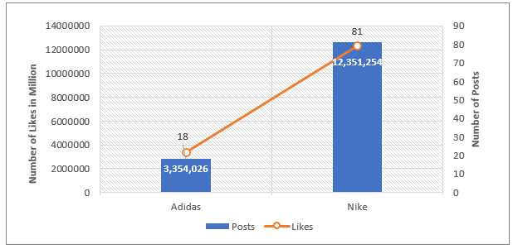
Figure 1. Number of posts and likes by Nike and Adidas from Oct 2022 – June 2023

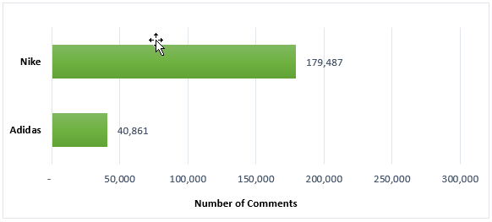
Figure 2. Number of posts and likes by Nike and Adidas from Oct 2022 – June 2023

Post Categorization
Reach and engagement metrics, encompassing of likes and comments received by both Nike and Adidas reflect the brand's overall visibility and engagement levels with its with consumers. Adidas has 18 postings overall, 128% fewer than Nike, which has 81 posts over the same time. Nike had 12,351,254 likes and 149,953 comments, while Adidas had 3,354,026 million likes and 40,861 co Sorting posts into distinct categories enables easier classification and evaluation of their content or purpose. This categorization facilitates comparison, and comprehension of post-performance, engagement, and effectiveness. The posts were categorized into “Product Promotion”, “Product Collaboration”, “Social Cause” and “Product Announcement”. Product Promotion includes the promotion of a shoe or apparel, and Product Collaboration is coded for posts that involve a product developed in collaboration with another company, celebrities, or athletes. Posts promoting social messages are categorized under social cause and product announcement involves introducing a new product. Adidas and Nike prioritize product marketing as their primary focus, accounting for 78% and 64% of their content. Social cause posts follow behind at 17% and 20%. Product collaboration posts are evenly distributed, making up 5% of both brands' content.
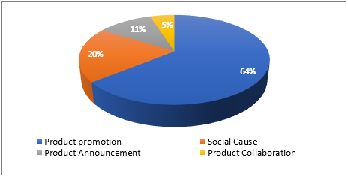
Figure 3. Breakdown of post category by Nike from Oct 2022 – June 2023
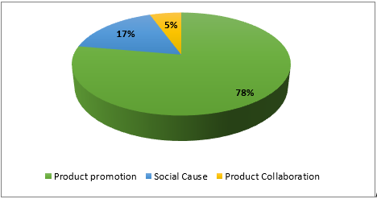
Figure 4. Breakdown of post category by Adidas from Oct 2022 – June 2023

Product Promotions:
When examining most of Nike's social media postings and advertising efforts, the company’s emphasis is on the people who actively utilize the products, including athletes from various countries, rather than placing an excessive amount of emphasis on the product themselves. To advertise its products, the company has teamed with well-known athletes and celebrities, and it has created social media campaigns to engage with customers on a more personal basis and thereby enhancing their reach to the influencer's following and increasing their digital presence. Numerous well-known athletes serve as Nike's spokespersons and brand influencers. Prominent athletes including LeBron James (basketball), Cristiano Ronaldo (football), Roger Federer (tennis), Michael Jordan (basketball), Serena Williams (tennis), and Rafael Nadal (tennis) have been featured in their most popular blogs. For example, LeBron James' post on February 8, 2023, earned 1,299,393 likes, exceeding the 230,196 average number of likes for product promotion from October 2022 to June 2023.Adidas follows a similar strategy Adidas, too, uses celebrity athletes and influencers in their marketing initiatives to boost brand awareness and appeal to a wider audience. Adidas' post promoting the FIFA World Cup 2022 on December 12, 2002, received 1,418,337 likes.

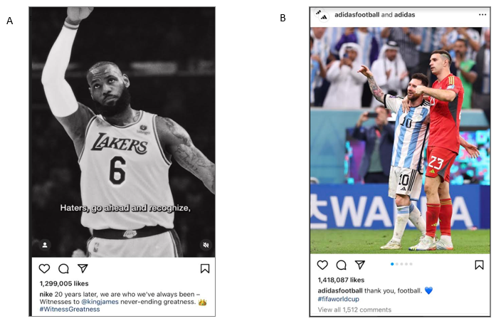
Figure 5. As seen in A, Nike post about LeBron James' on February 8, 2023, earned 1,299,393 likes and figure B is a post by Adidas' post promoting the FIFA World Cup 2022 on December 12, 2002, that received 1,418,337 likes.

Product Collaboration:
Both Nike and Adidas collaborated with high-profile celebrities and brands, capitalizing on the energy generated by their modern design advancements, consumer needs, and massive reach, all of which are critical to the brand's success.
Social Causes:
The quickest way to gain the respect and trust of the people you interact with is by getting involved in the community. Adidas and Nike have publicly demonstrated their dedication to social justice, equality, and sustainability. They have successfully used their platforms to raise awareness and encourage constructive change while adopting a marketing strategy that revolves around partnering with social causes and tackling urgent matters. Nike has an average of 1764 comments and 134,423 likes per post on social causes. Adidas has an average of 1764 comments and 1,764 likes per post on social causes. Nike’s Instagram bio includes hashtags #BlackLivesMatter and #StopAsianHate while Adidas striving to put an end to racism and hate while Adidas with its "Impossible is Nothing" campaign, which aims to encourage women who are taking down barriers in sport and other spheres.
Nike received the highest number of likes per post on average for product collaboration, followed by product promotion, and then social cause posts. Conversely, Adidas's top-performing posts in terms of engagement are product promotion, followed by product collaboration, and then social cause posts.
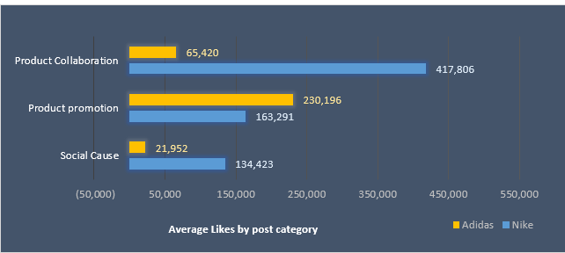
Figure 6. Number of posts and likes by Nike and Adidas from Oct 2022 – June 2023

Day of the week for the posts:
The level of engagement on Adidas’s posts increased noticeably over the weekend, especially on Sundays. However, for over 77% the posts, there was no clear association between the percentage of posts and the level of engagement. The only exception was that the second largest number of postings occurred on Sundays, which also happened to be the day with the highest amount of participation.
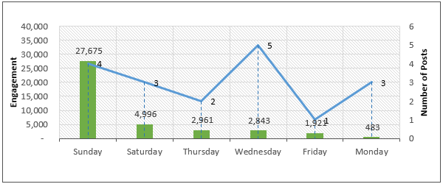
Figure 7. Adidas- Engagement (Likes+ Comments) based on the Day of the week from Oct 2022 – June 2023

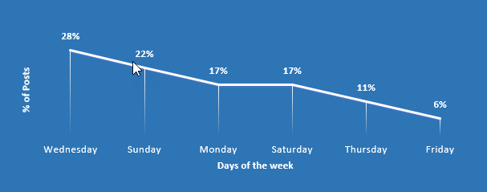
Figure 8. Adidas - Percentage of Post by day of the week from Oct 2022 – June 2023

The engagement on Nike significantly increased during the workweek, especially on Wednesday, Thursday, and Tuesday. Among these days, the engagement was the best on Wednesdays. Nike seems to acknowledge this data, as there is an evident connection between the percentage of posts and the level of engagement observed during these specific days.

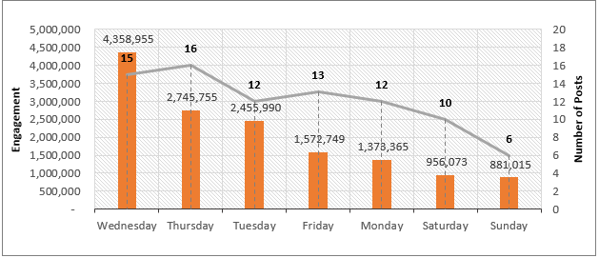
Figure 9. Nike-Engagement (Likes+ Comments) based on the Day of the week from Oct 2022 – June 2023

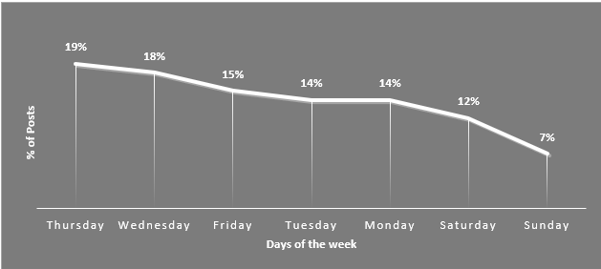
Figure 10. Nike - Percentage of Post by day of the week from Oct 2022 – June 2023

Nike and Adidas have kept the reputations of their respective brands and built strong brand values over time. The social media strategies of these two sports brands are very similar in many aspects. Both companies emphasize their customers as brand ambassadors and user-generated content to expand their reach and increase brand awareness during promotions rather than just promoting the products they sell. Both Nike and Adidas utilize their platforms to support social concerns. They have made a point of using these platforms to promote social justice, diversity, and sustainability, spreading the word and inciting change.

Conclusion

The study examined the influence of Nike and Adidas' social media marketing strategies on their brand awareness, engagement, and their target customer reach globally. Global target audiences can be reached via social media marketing effectively given there are 2 billion monthly active users on Instagram (Biggest Social Media Platforms 2023 | Statista, 2023). Over 60% of Instagram's user base is between the ages of 18 and 34 (Zote, 2023), and the platform is ideal for brands like Nike, whose target market is also between the ages of 18 and 44 (Carmely, 2023). Internal Instagram data show that 50% of people get more interested in a brand after viewing an Instagram ad for it. This speaks volumes about the effectiveness of Instagram advertising for your business (Zote, 2023). Companies must therefore carefully select marketing tools that support solid relationships to influence consumer behavior and guarantee sustainable business profitability over time. (Wibowo et al., 2020). One limitation of this study is that only a small sample of postings from a single social media account were examined because of the manual coding and data gathering methods used. As such, future research should be more in-depth to gain a more comprehensive understanding of how social media marketing affects customer buying behavior.
Connecting with targeted audiences, promoting customer interaction to raise brand awareness while encouraging brand loyalty, and gathering insightful information about current trends and consumer mood are the main goals of social media. Based on the observations by the two shoe brands, here are the key strategies to increase the effectiveness of the social media marketing:
- Selecting the right social media platform: Consider the social media platform from the numerous available options that is best for your company based on your target market. For instance, Nike's target audience is made up of people between the ages of 18 and 40 (Carmely, 2023), and the two social media platforms they frequently use for their postings are Instagram and Twitter. More than 60% of the age range using Instagram are 18 to 34 (Instagram: Age Distribution of Global Audiences 2023 | Statista, 2023) and 70% of Twitter is 18 to 49 (Twitter: Age Distribution of Global Audiences 2021 | Statista, 2022).
- Promotion strategy: Promotions from Nike and Adidas go beyond just promoting their products; instead, they center on the customers who use them, who take on the role of the brand's spokesperson and value user-generated content. The two companies increase their digital footprint and gain free promotion by encouraging customers to use the company's hashtags to share their experiences and stories. Inspiring individuals to achieve their goals while wearing the brand's clothing, Nike's "Just Do It" and Adidas's "Impossible Is Nothing" hashtags create a strong emotional connection between customers and businesses.
- Collaborations and partnerships have the power to influence the public perception of a company's products or services. LeBron James, who has 156 million Instagram followers, and Lionel Messi, who has a whopping 479 million followers, are two examples of partnerships that has enabled the two brands, Nike, and Adidas to improve their online presence and interact with the influencer's sizable audience.
- Content strategy and format: According to Zote (2023), Short video material, such as reels, has shown to be the most effective method for improving Instagram interaction, closely followed by photos. Trend research on the top-performing posts might provide significant insights into the target audience's preferred content type.
- Choosing the day and time for the posts: Posting on an optimal day and time increases the chances of getting more likes, comments, and reach. Using the information acquired in earlier posts, it may be possible to determine the best day and hour to maximize engagement from your followers.
- Creating a community for individuals boosts the brand's trust: Nike has various accounts dedicated to football, basketball, women, apparel, and running, which allows them to acquire insights and tailor their audience's needs. Similarly, Adidas women has gained traction with a flawless demonstration of how the brand adjusted its content to address their target group.
Although no marketing activity is free, social media marketing is far less expensive than traditional marketing tactics and has the potential to reach a larger target audience globally. According to Gilpin (2023), building brand loyalty and reputation is of utmost importance in the current economic climate. A remarkable 96% of corporate leaders feel that ongoing investments in social media are critical for success and that social media plays a critical role in maintaining long-term organizational viability.

.

References
Biggest social media platforms 2023 | Statista. (2023, February 14). Statista. https://www.statista.com/statistics/272014/global-social-networks-ranked-by-number-of-users/

Cao, D., Meadows, M., Wong, D., & Xia, S. (2020). Understanding consumers’ social media engagement behaviour: An examination of the moderation effect of social media context. Journal of Business Research, 122(122), 835–846. https://doi.org/10.1016/j.jbusres.2020.06.025

Carmely, M. (2023b). Nike Target Market Segmentation – Customer Analysis & Marketing Goals for 2022. Start.io - a Mobile Marketing and Audience Platform. https://www.start.io/blog/nike-target-market-analysis/

Digital vs. traditional marketing budget changes according to U.S. CMOs 2023 | Statista. (2023, July 4). Statista. https://www.statista.com/statistics/693449/digital-vs-traditional-marketing-budget-change-according-to-cmos-usa/

Digital ad spend worldwide 2026 | Statista. (2023, March 1). Statista. https://www.statista.com/statistics/237974/online-advertising-spending-worldwide/

Gilpin, J. (2023). The state of social media 2023: Business leaders weigh in on what’s next. Sprout Social. https://sproutsocial.com/insights/the-state-of-social-media/

Instagram: age distribution of global audiences 2023 | Statista. (2023, February 14). Statista. https://www.statista.com/statistics/325587/instagram-global-age-group/

Kemp, S. (2023). Digital 2023 April Global Statshot Report — DataReportal – Global Digital Insights. DataReportal – Global Digital Insights. https://datareportal.com/reports/digital-2023-april-global-statshot

Kraus, E., & Rico, A. R. (2023, May 17). Everything you need to know about TV advertising costs. Fit Small Business. https://fitsmallbusiness.com/tv-advertising/

Li, F., Larimo, J., & Leonidou, L. C. (2020). Social Media Marketing strategy: definition, conceptualization, taxonomy, validation, and Future Agenda. Journal of the Academy of Marketing Science, 49(1), 51–70. Springer. https://doi.org/10.1007/s11747-020-00733-3

Lim, W. M. (2023). Transformative marketing in the new normal: A novel practice-scholarly integrative review of business-to-business marketing mix challenges, opportunities, and solutions. Journal of Business Research, 160, 113638. https://doi.org/10.1016/j.jbusres.2022.113638

Mehmeti-Bajrami, S. M.-B., Qerimi, F., & Qerimi, A. (2022). The Impact of Digital Marketing vs. Traditional Marketing on Consumer Buying Behavior. HighTech and Innovation Journal, 3(3), 326–340. https://doi.org/10.28991/hij-2022-03-03-08

U.S. Twitter reach by age group 2021 | Statista. (2022, April 27). Statista. https://www.statista.com/statistics/265647/share-of-us-internet-users-who-use-twitter-by-age-group/

Wang, H. (2015). Analysis on the Changes in Consumer Behavior and Marketing Countermeasure. SHS Web of Conferences. https://doi.org/10.1051/shsconf/20151701007

Wibowo, A., Chen, S., Wiangin, U., Ma, Y., & Ruangkanjanases, A. (2020). Customer Behavior as an Outcome of Social Media Marketing: The Role of Social Media Marketing Activity and Customer Experience. Sustainability, 13(1), 189. https://doi.org/10.3390/su13010189

Zote, J. (2023). 13 Ways to increase your Instagram engagement rate. Sprout Social. https://sproutsocial.com/insights/instagram-engagement/

